

REPORT OF WORLD ORAL HEALTH DAY/ MONTH CELEBRATION 2026

Oral health is an important component of overall well-being of an individual. The Bangkok Declaration has stated “No Health without Oral Health” to stress the importance of Oral Health and its significance in overall health. The department of Public Health Dentistry, Pushpagiri College of Dental Sciences organized several programmes to enhance the oral health awareness and to improve the oral health of the community. The population covered included school children, teenagers, adults, elderly population and vulnerable groups like orphanages and old age homes.
The various programmes conducted were;
- Dental Exhibition
- Fun Games
- Smile Contest
- Radio Oral Health education programmes
- Dental Screening and treatment Camps
- Creation of two Oral Health awareness videos- Importance of topical fluoride and Dental Sensitivity
Total Number of beneficiaries of programmes: 14,01555
Organising Team
Dr Benley George Dr Ansu Emmanuel
Dr Sunu Alice Cherian Dr Denny Thomas Dr Ruby Mary Philip

Dr Benley George
Prof and HOD
Dept of Public Health Dentistry

Date: 19/03/26 Time: 8.30 am-3.00 pm Venue: Foyer, PCDS

Organized by: Department of Public Health Dentistry

In observance of World Oral Health Month, World Oral Health Day was commemorated on 19th March 2026 at Pushpagiri College of Dental Sciences. The event was organized by the Department of Public Health Dentistry with the aim of creating awareness about the importance of oral hygiene and preventive dental care among the public.
Several activities were conducted during the month of March and April for the benefit of the community which included;
- Dental Check up and Dental treatment Camps
- Dental Exhibition
- Smile Contest
- Radio Oral Health Education Programmes
- Creation of two Oral health Awareness Videos
- Fun Games
Dental Exhibition
A Dental exhibition was conducted in the foyer of the college from 8:30 AM to 3:00 PM. All nine departments actively participated by setting up individual stalls. The stalls were set up by the department of Oral Medicine and Radiology, Oral and Maxillofacial Surgery, Pedodontics, Public Health dentistry, Periodontics, Orthodontics, Conservative Dentistry and Endodontics, Prosthodontics and Crown and Bridge and Oral and Maxillofacial Pathology. Each department presented informative exhibits including models, posters, flyers, and flip charts to effectively communicate various aspects of oral health and dental care. Visitors were educated on proper brushing techniques, dental flossing, maintenance of oral hygiene, and recent advancements in dentistry. The exhibition served as an interactive platform for patients and the general public to gain knowledge and clarify their doubts regarding oral health.
No of Beneficiaries: 370
Fun Games
To enhance participation and engagement, various fun activities and games were organized, all with the primary objective of spreading awareness about oral health in an enjoyable manner. Winners were awarded with prizes on the same day.
No of Beneficiaries- 66

Smile Contest
A Smile Contest was also conducted on the same day, which included three categories: patients, students, and teaching and non-teaching staff. The contest encouraged participants to showcase healthy smiles and highlighted the importance of maintaining good oral hygiene. An award ceremony was conducted on 26th march 2026 and all the winners were awarded prizes.
The department of Public Health Dentistry had created a public awareness video for adults on dental sensitivity and Importance of fluoride application for children. This educational video was also released on the same day.
Overall, the event was a great success, witnessing active participation from students, faculty, and the public, thereby fulfilling its objective of promoting oral health awareness.
No of Beneficiaries- 277
No of participants (other than PCDS

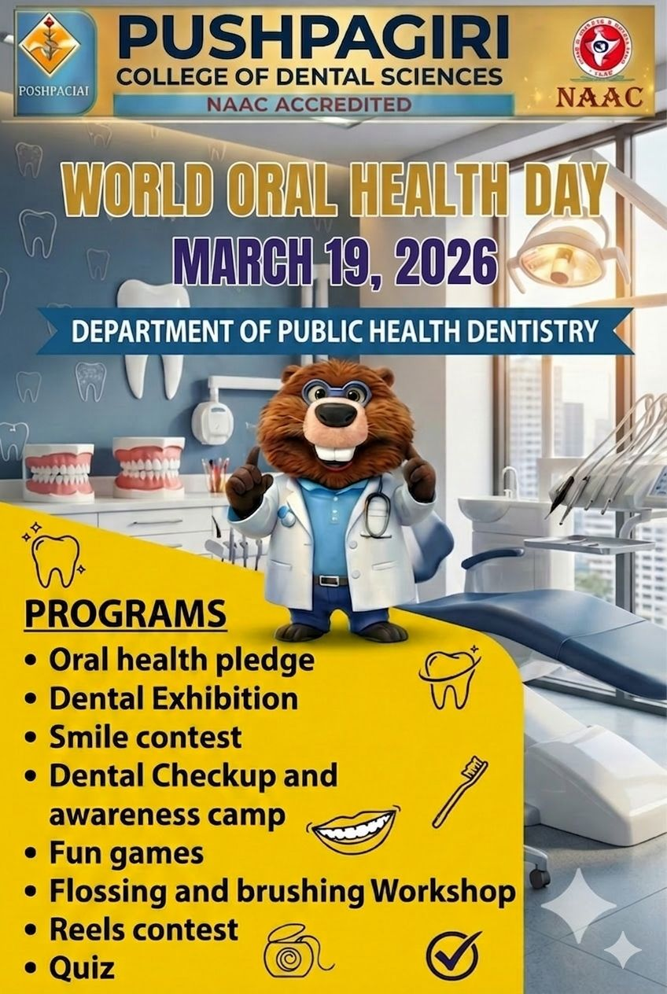
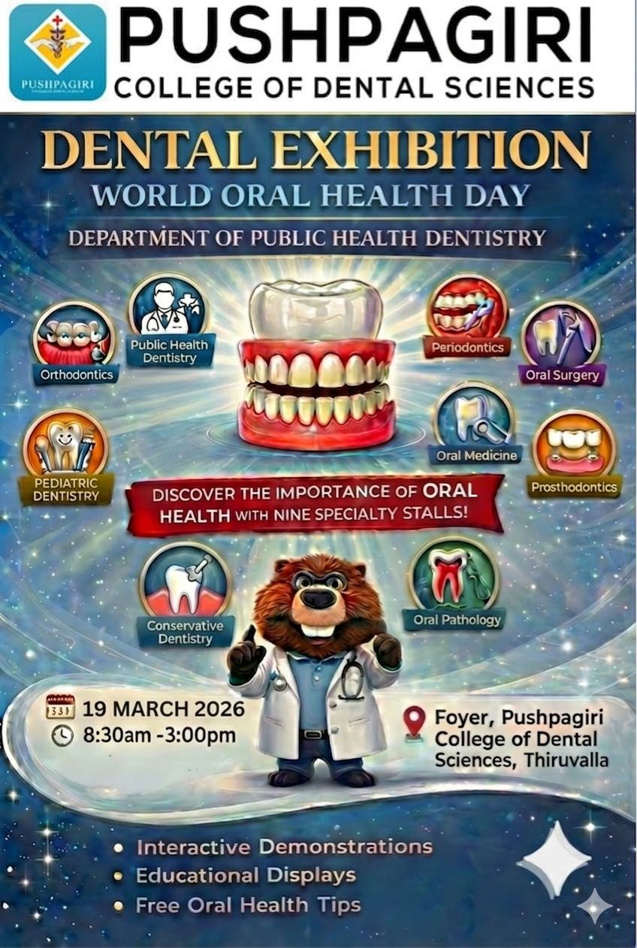

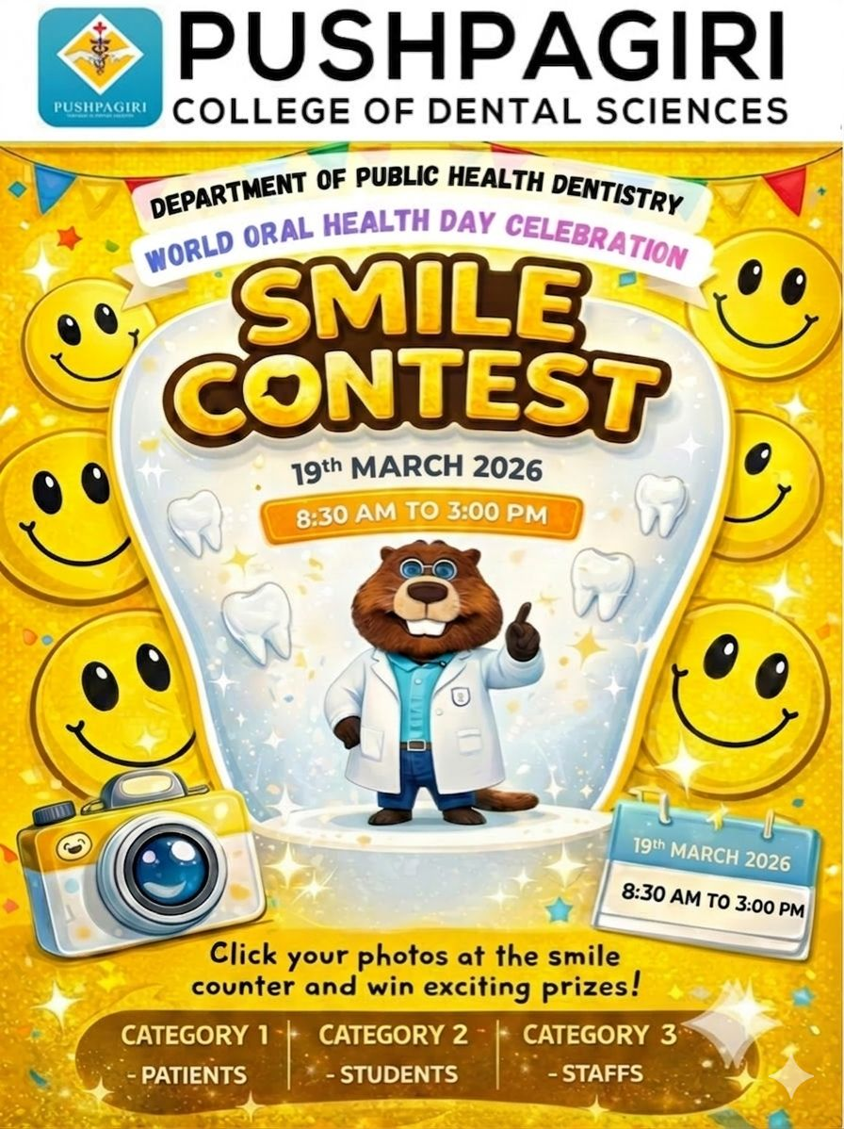

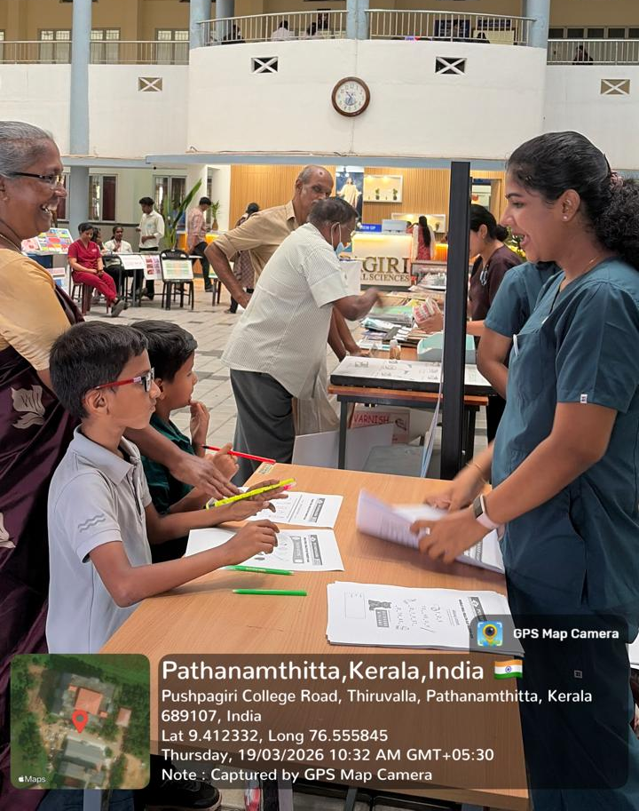
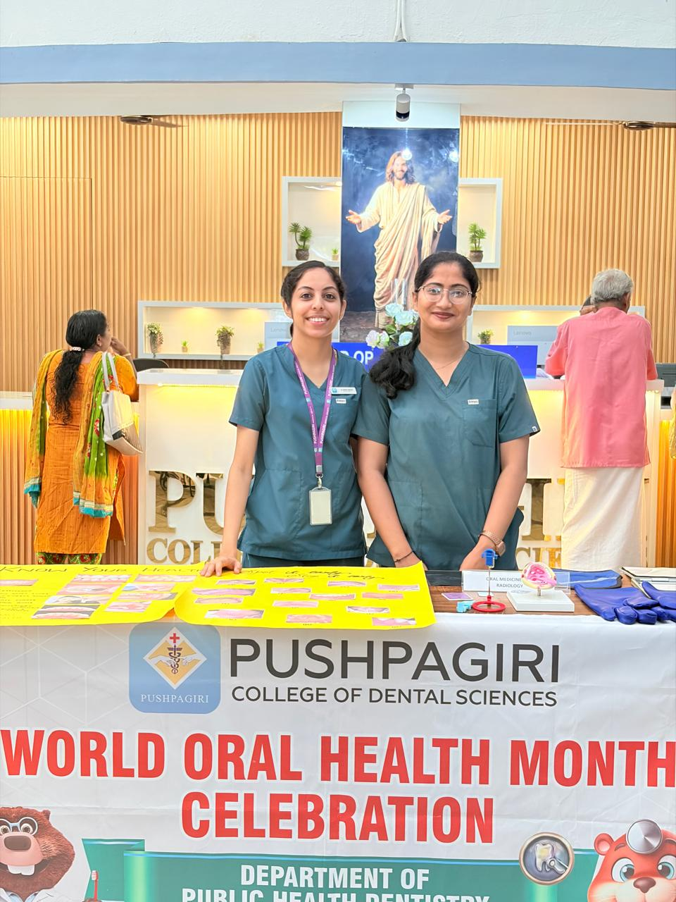

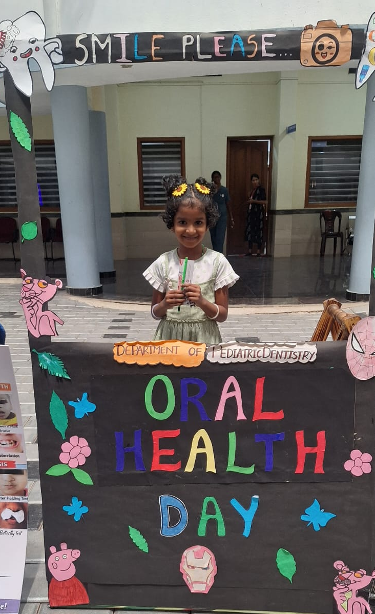
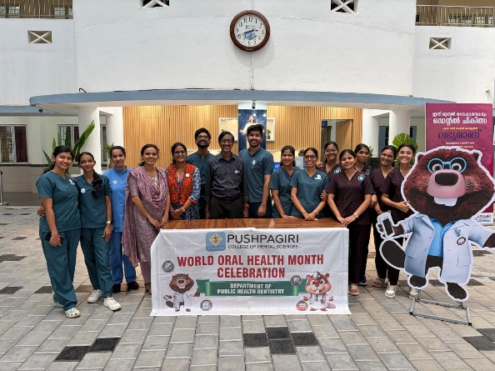

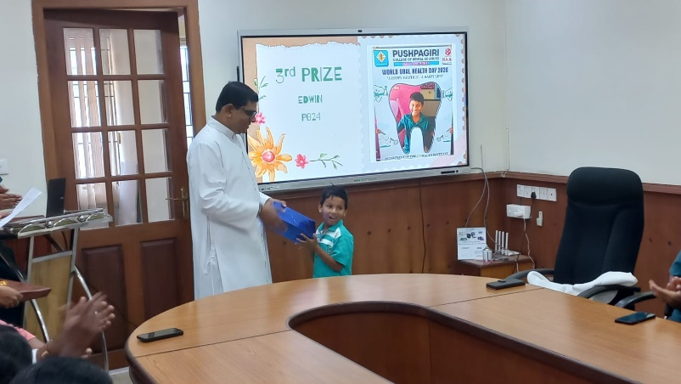

Radio Oral Health Education Programme- Radio Macfast 90.4 FM station, Thiruvalla

To promote oral health awareness among the community several oral health education programmes were conducted in March at Radio Macfast 90.4 FM station, Thiruvalla.

S No | Date and Time | Topic | Name of Speakers
1 | 05-03-26, 2-3pm | Healthier smiles with routine oral prophylaxis | Dr Rino Roopak Soman and Dr Irene Elizabeth Jose
2 | 06-03-26, 2-3pm | National Dentist Day | Dr Vinod Mathew
3 | 20-03-26 1-3pm | Importance of Maintaining good oral health  Introduction to Oral Health  Specialities in Dentistry  Microscopic Root Canal Treatment  Oral Health Check up  Pediatric dental check up  Oral cancer | Dr Annie Kitty George and Dr Prameetha George  Dr Devadathan A  Dr Benley George  Dr Jose Jacob and Dr Minimol K Johny  Dr Anlin Anto  Dr Alisha T Susan  Dr Eva Rachael
4 | 26-02-26,  2-3pm | Diabetis and Periodontitis | Dr Rino Roopak Soman and Dr Maria Kachiramattom
No of beneficiaries- 1395537

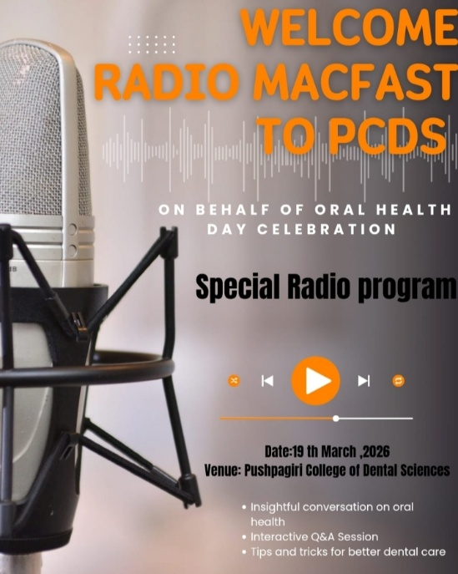
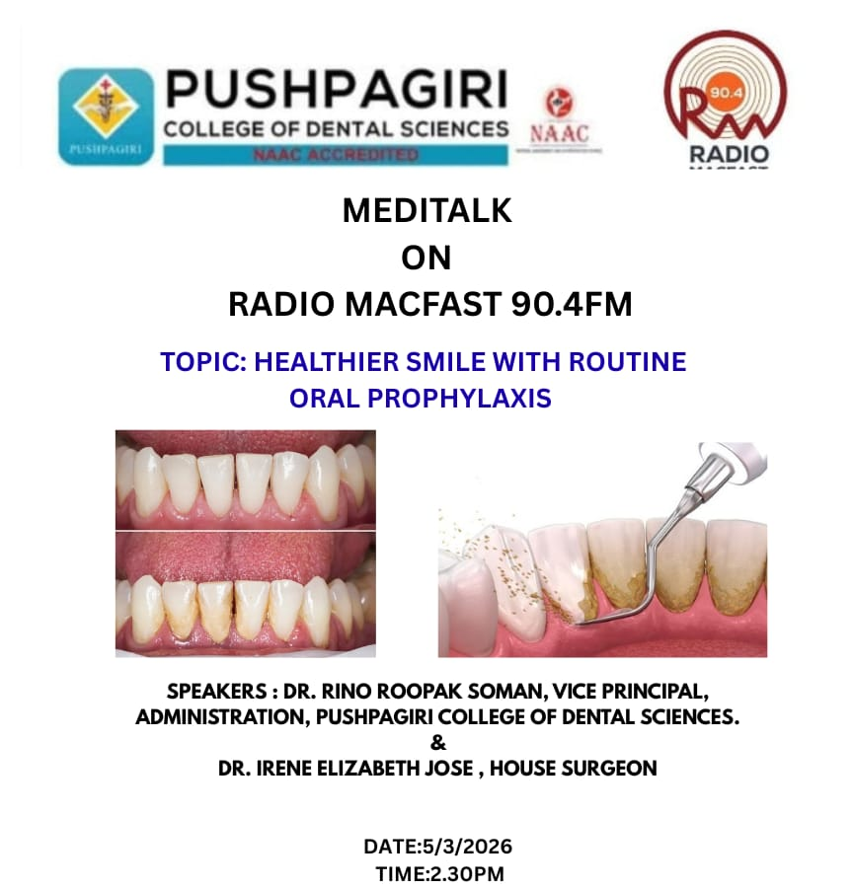

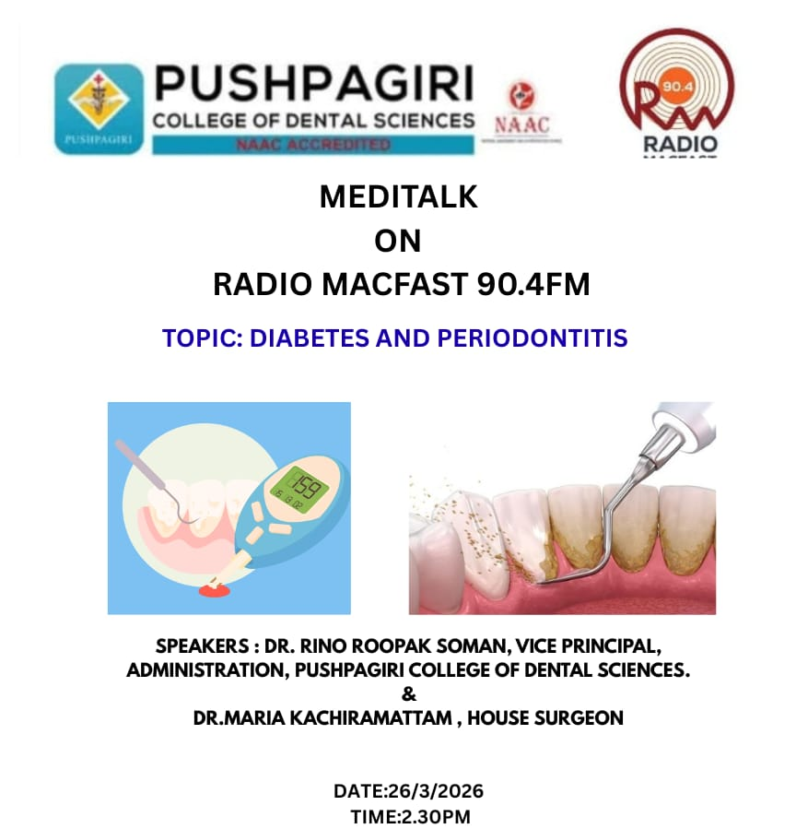

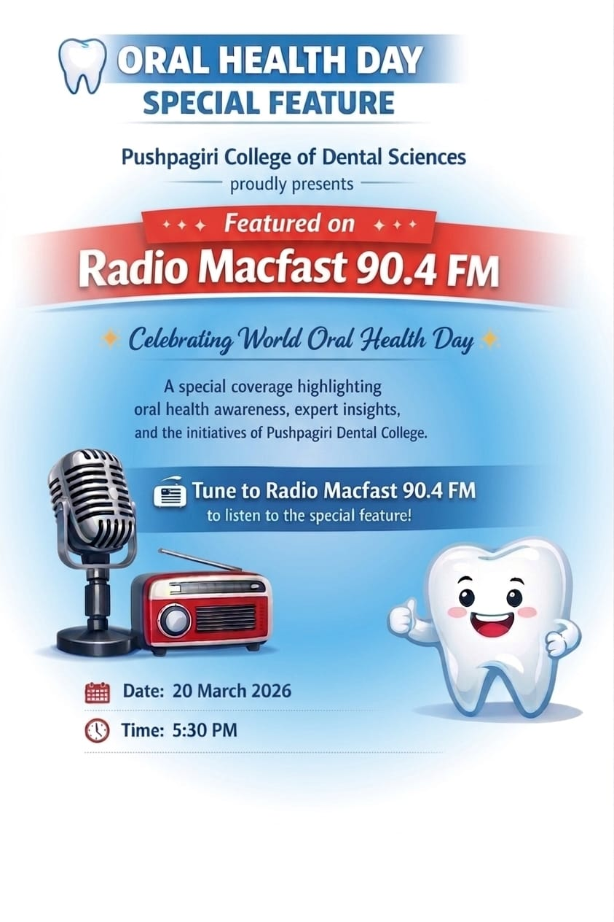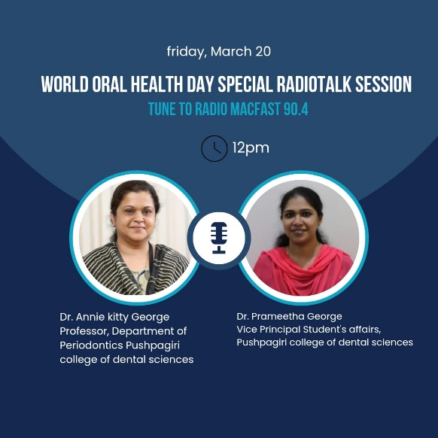

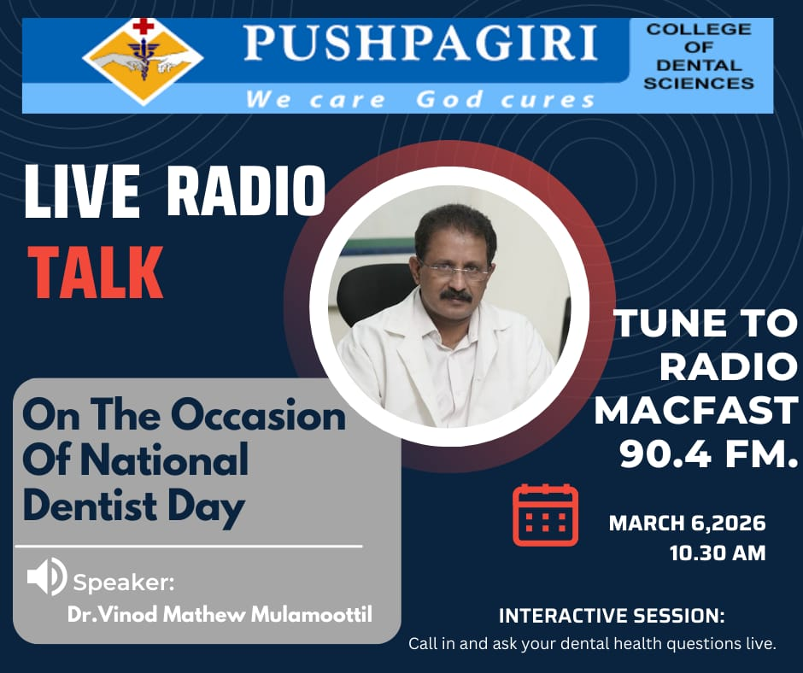

DENTAL CAMP REPORTS

Venue: Devaswom board school, Kangazha

Date: 06.01.2026 Time : 10.00-2.00pm

No of patients: 91

Sl no | Gender | Decay(%) | Gum disease(%) | Malocclusion(%)
1 | Males (48) | 35.4 | 35.4 | 31.2
2 | Female (43) | 25.5 | 37.2 | 34.8

Date: 07.01.2026 Time: 9:30 AM - 1.30 PM

Venue: Govt. Higher Secondary School, Peringara

CAMP STATISTICS

No of Participants: 129

Sl no | Gender | Decay(%) | Gum disease(%) | Malocclusion(%)
1 | Males (60) | 20 | 50 | 11.8
2 | Female (69) | 23.1 | 21.7 | 28.9

Venue: GHS Model High School, Thiruvalla

Date: 08.01.2026 Time : 10.00-2.00pm

CAMP STATISTICS

No of patients: 39

Sl no | Gender | Decay(%) | Gum disease(%) | Malocclusion(%)
1 | Males (3) | 16.6 | 50 | 66.6
2 | Female (36) | 36.3 | 48.4 | 33.3

Venue: Mar Saverios College of Teacher Education

Date: 09.01.2026 Time : 10.00am-2.00pm

CAMP STATISTICS

No of Participants: 48

Sl no | Gender | Decay(%) | Gum disease(%) | Malocclusion(%)
1 | Males (5) | 60 | 40 | 40
2 | Female (43) | 35 | 44 | 65

Venue: Marthoma church, Venpala

Date: 10/01/2026 Time: 9.00 am-1.00pm

CAMP STATISTICS

No of patients: 17

Sl no | Gender | Decay(%) | Gum disease(%) | Malocclusion(%)
1 | Males (9) | 55 | 77 | 44
2 | Females (8) | 75 | 87 | 50

Venue: Pushpagiri Rural Health Center, Pulinkunnu

Date: 10.01.2026 Time : 09.00am-3.00pm

CAMP STATISTICS

No of patients: 11

Sl no | Gender | Decay(%) | Gum disease(%) | Malocclusion(%)
1 | Males (7) | 100 | 72 | 42
2 | Females (4) | 75 | 25 | 50

Venue: Shri Adwayanandha Public School, Malakkara

Date: 13.01.26 Time :9.30-2.00pm

CAMP STATISTICS

No of patients: 104

Sl no | Gender | Decay(%) | Gum disease(%) | Malocclusion(%)
1 | Males (69) | 26 | 31.8 | 28.9
2 | Females (35) | 25.7 | 28.5 | 14.2

Venue: Mount Carmel Vidyaniketan, Kanjikuzhy

Date: 14.01.2026 Time: 9.45am-2.00pm

CAMP STATISTICS

No of patients: 351

Sl no | Gender | Decay(%) | Gum disease(%) | Malocclusion(%)
1 | Males (164) | 60 | 30.3 | 42
2 | Females (187) | 58 | 20.2 | 50

Venue: MOUNT CARMEL VIDYANIKETAN, KANJIKUZHY

Date: 15.01.2026

Time : 9.30am-2.30pm

CAMP STATISTICS

No of patients: 364
Sl no | Gender | Decay(%) | Gum disease(%) | Malocclusion(%)
1 | Males (159) | 35.2 | 49.0 | 29.5
2 | Female (205) | 32.6 | 30.7 | 29.7

Venue: Lions Club, Changanassery

Date: 17.01.2026 Time: 9.45 am - 2.00 pm

CAMP STATISTICS

No of Patients: 31

Sl no. | Gender | Decay (%) | Gum  Disease (%) | Malocclusion (%)
1 | Males(20) | 50 | 80 | 30
2 | Female(11) | 27.3 | 73 | 27.3

Venue: Labour India Gurukulam Public School

Date: 19/01/2026 Time: 10:30am – 1:30pm

Camp Statistics:

No of Patients: 156

Sl no. | Gender | Decay (%) | Gum  Disease (%) | Malocclusion (%)
1 | Males(118) | 24.5 | 12.7 | 32
2 | Female(38) | 50 | 7.8 | 23.6

Venue: Mor Serverios Higher Secondary School,Ranni

Date: 19.01.2026 Time: 10.00am-1.00pm

CAMP STATISTICS

No of patients: 45

Sl no | Gender | Decay (%) | Gum disease (%) | Malocclusion (%)
1 | Males (26) | 34 | 50 | 65
2 | Female (19) | 57 | 21 | 63

Venue: Lions Club, Chengannur

Date: 24.01.26

Time: 8:45 am - 3:00 pm

CAMP STATISTICS

No. Of patients: 62

Sl no | Gender | Decay (%) | Gum disease (%) | Malocclusion (%)
1 | Males (34) | 32.3 | 67.6 | 6
2 | Female (28) | 68 | 78.5 | 10

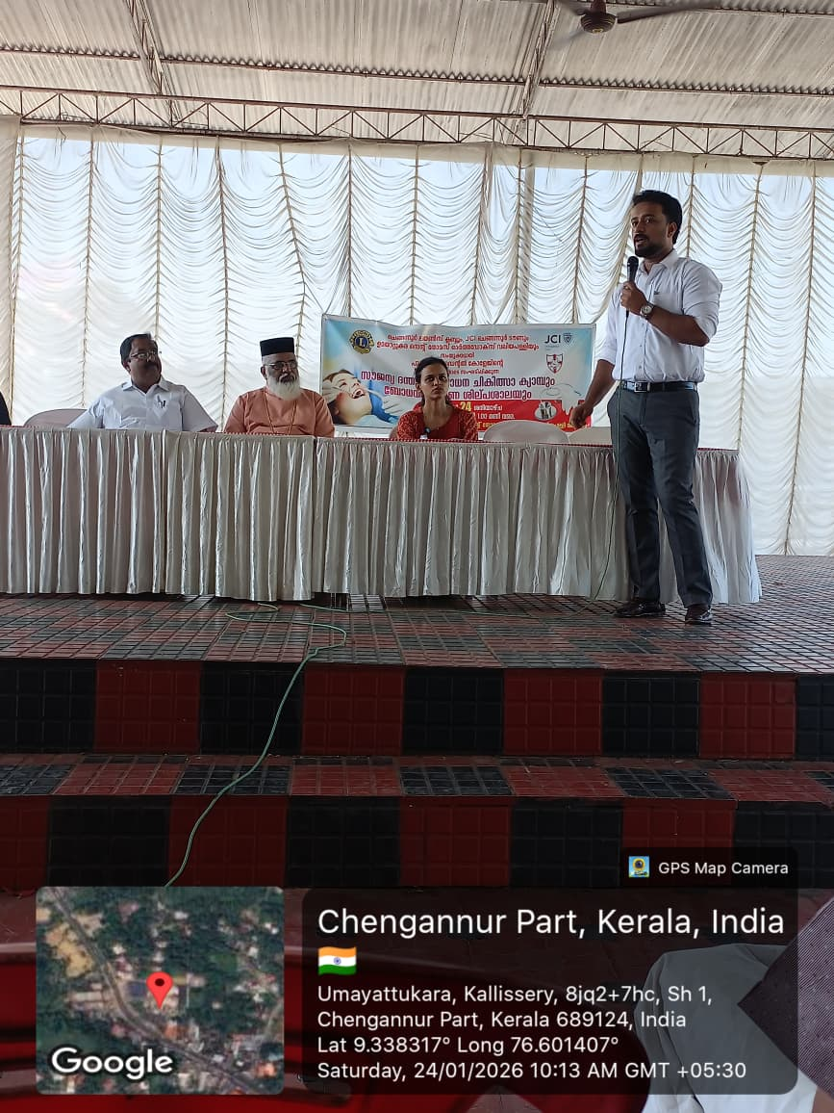

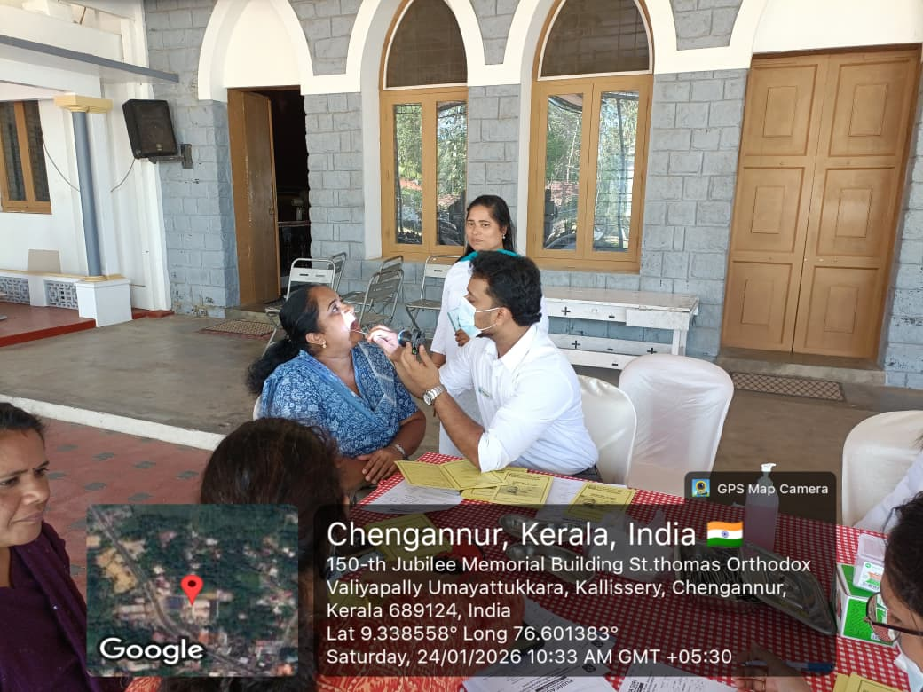

Venue: Excelsior English School,Kottayam

Date: 29.01.2026

Time: 9.45 am - 2.00 pm

CAMP STATISTICS

No. Of patients: 312

Sl no | Gender | Decay (%) | Gum disease (%) | Malocclusion (%)
1 | Males (159) | 37 | 12 | 12
2 | Female (153) | 38.9 | 11 | 11

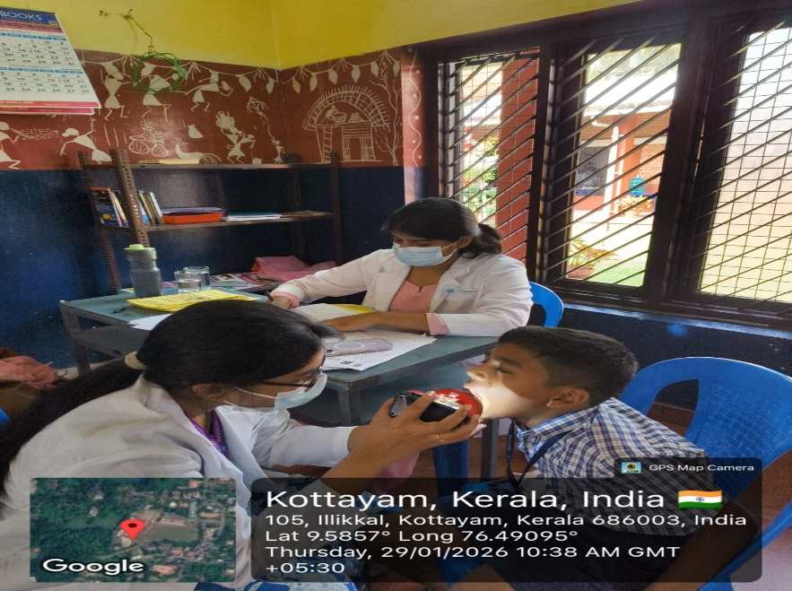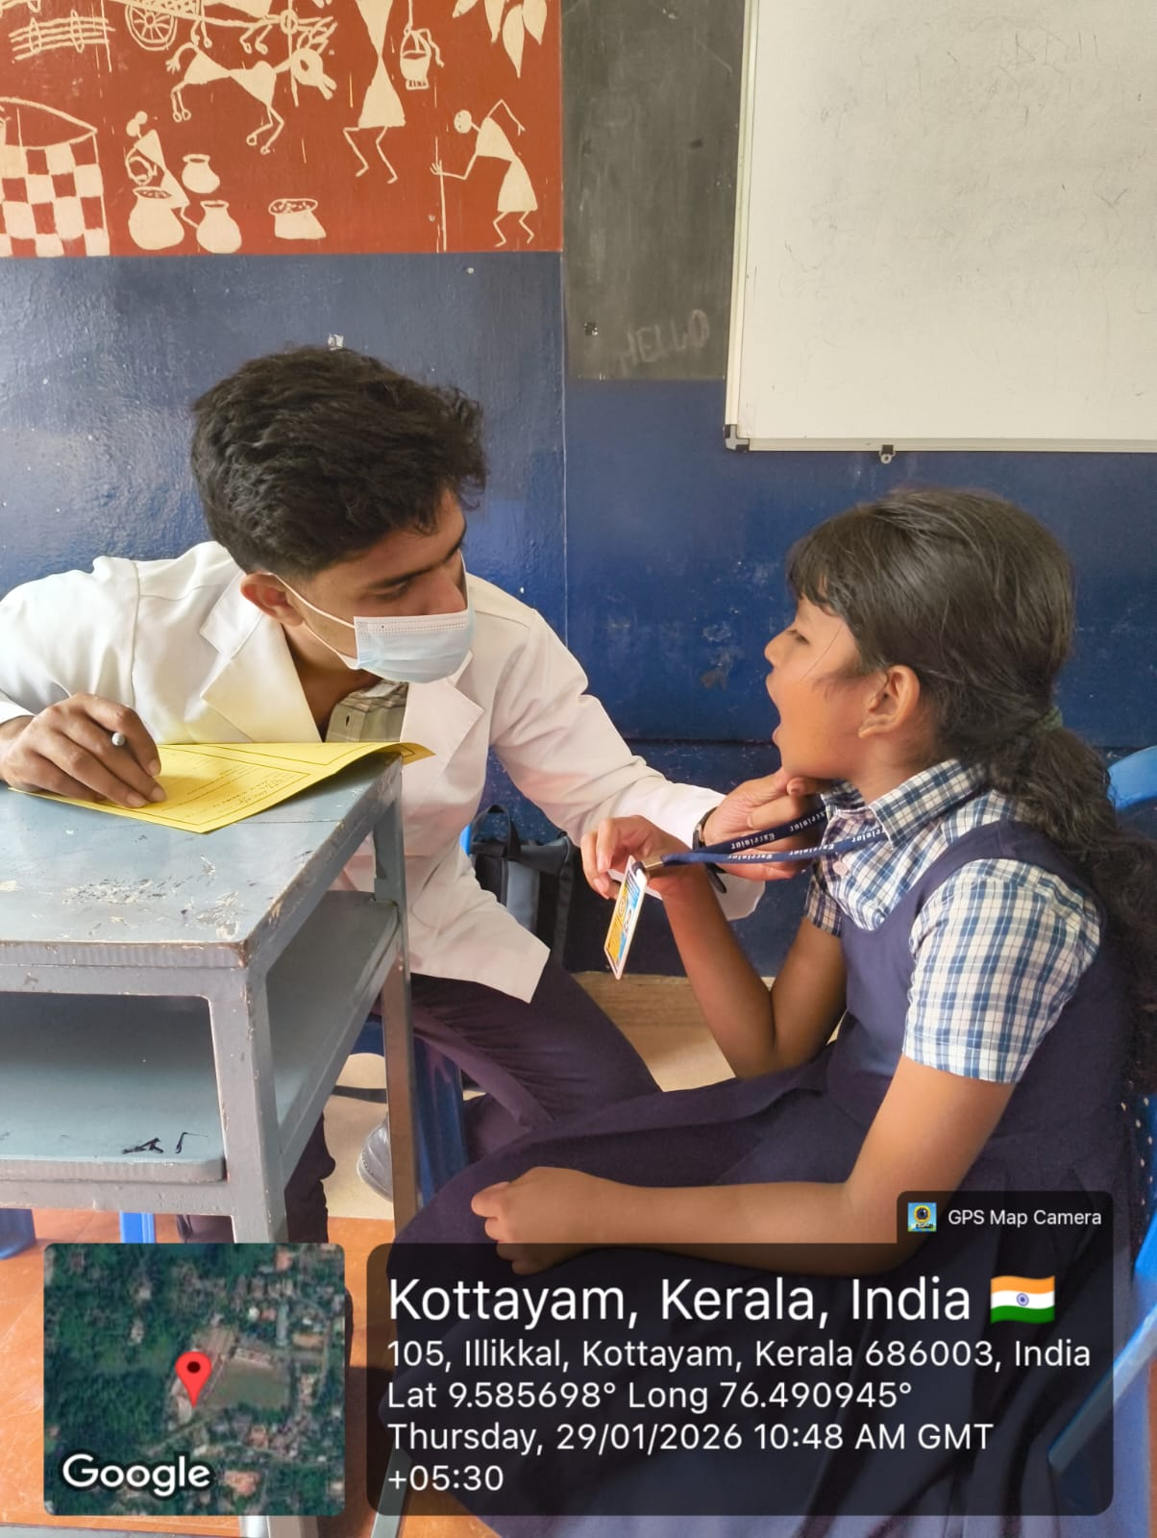

Venue: Lions Club, Mamood, Changanacherry

Date: 31.01.2026

Time: 9.45 am - 2.00 pm

CAMP STATISTICS

No. Of patients: 28
Sl no | Gender | Decay (%) | Gum disease (%) | Malocclusion (%)
1 | Males (11) | 72.7 | 100 | 18.1
2 | Female (17) | 82.3 | 88.2 | 29.4

Venue: CLEMIS SCHOOL, CHINGAVANAM

Date: 04.02.2026

Time: 9.30am-2.30 pm

CAMP STATISTICS

No of patients: 287

Sl no | Gender | Decay (%) | Gum disease (%) | Malocclusion (%)
1 | Males (127) | 20.4 | 59.8 | 40.1
2 | Female (160) | 23.7 | 49.3 | 43.1

Venue: Junior Baselious School, Pampaddy

Date: 06.02.26

Time: 10:00 am - 2.30 pm

Camp Statistics

No of Patients: 154

Sl no | Gender | Decay (%) | Gum disease (%) | Malocclusion (%)
1 | Males (76) | 61 | 17 | 22
2 | Females (78) | 62 | 93 | 23

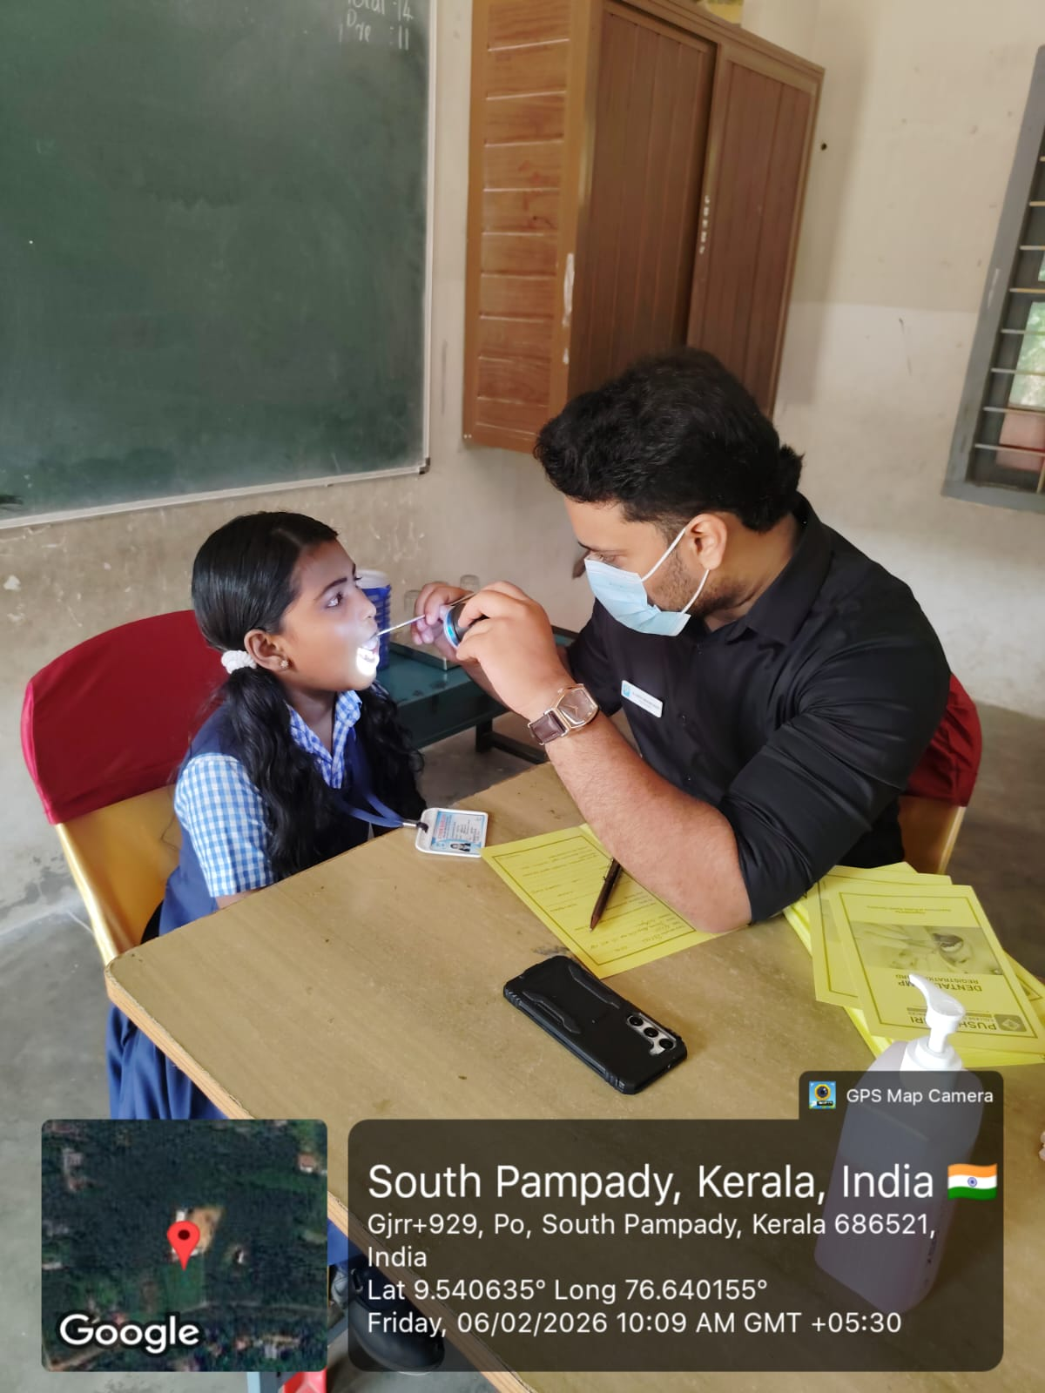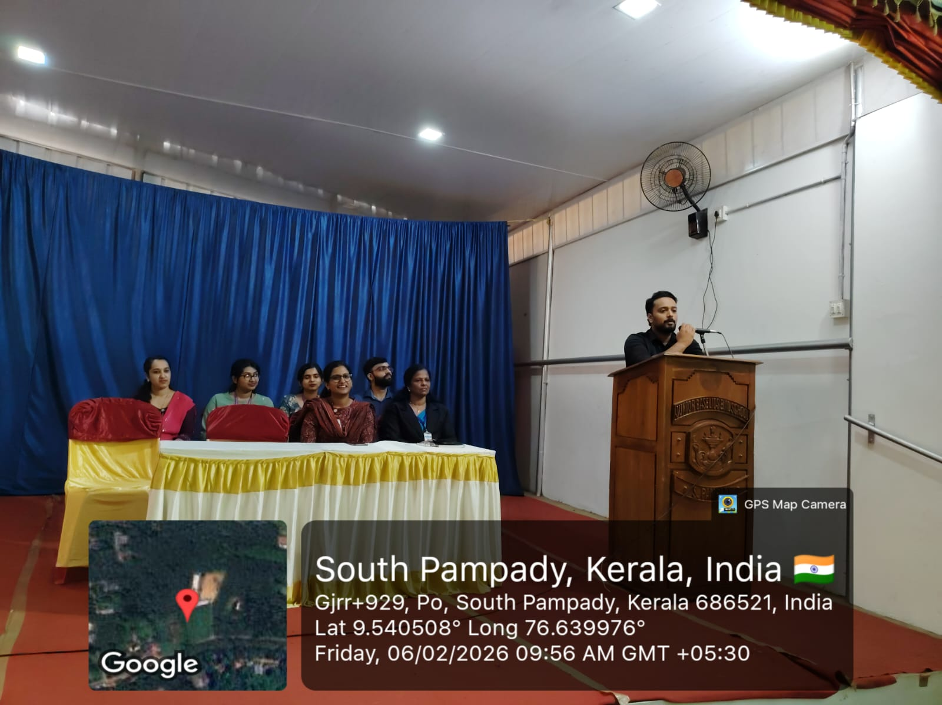

Venue: Snehatheerum Venpala, Thiruvalla

Date: 14.02.26 Time: 9.45-2pm

CAMP STATISTICS

● No of patients: 48

Sl no | Gender | Decay (%) | Gum disease (%) | Malocclusion (%)
1 | Males (27) | 51.8 | 18.5 | 7.4
2 | Females (21) | 57.1 | 28.5 | 4.7

Venue: St Alphonsa Public School, Kudamaloor

Date: 26.02.2026 Time: 9.45am-2pm

CAMP STATISTICS

No of patients: 278

Sl no | Gender | Decay (%) | Gum disease (%) | Malocclusion (%)
1 | Males (147) | 44.2 | 61.2 | 47.6
2 | Females (131) | 44.2 | 65.6 | 43.5

Venue: Bishop Moore College, Kallumala

Date : 27-02-2026 Time: 10:00 am -1:00pm

CAMP STATISTICS

No. Of patients: 70

Sl no | Gender | Decay (%) | Gum disease (%) | Malocclusion (%)
1 | Males (34) | 59 | 32 | 45
2 | Females (36) | 71 | 44 | 42

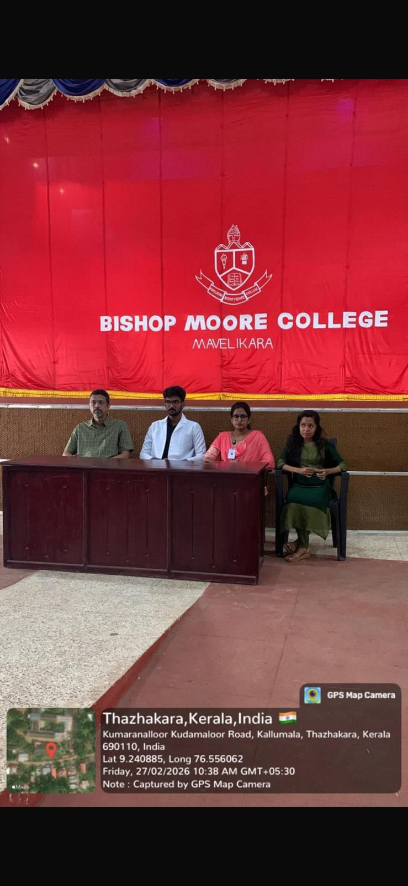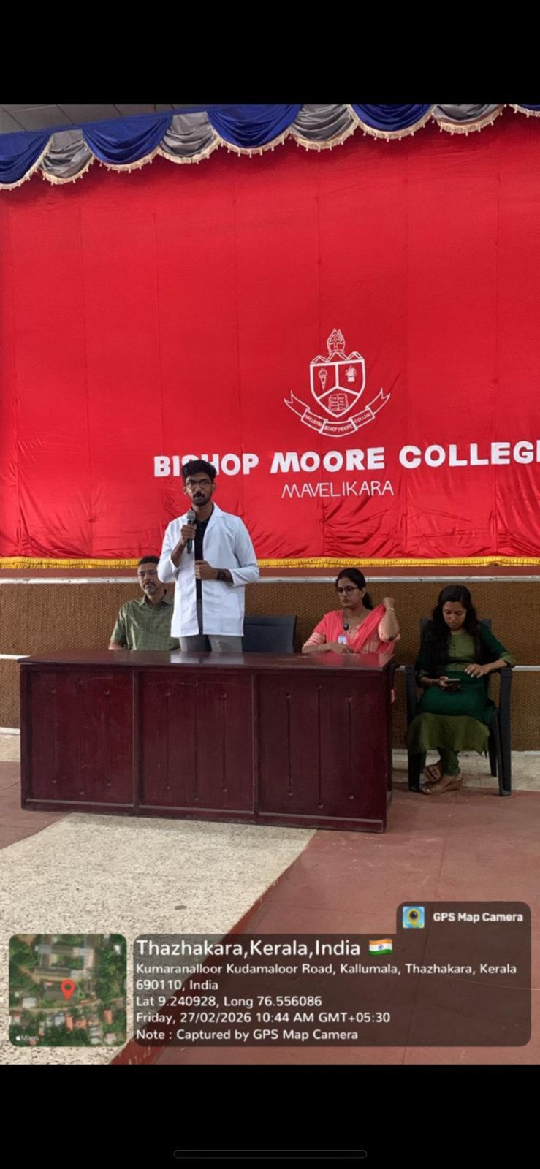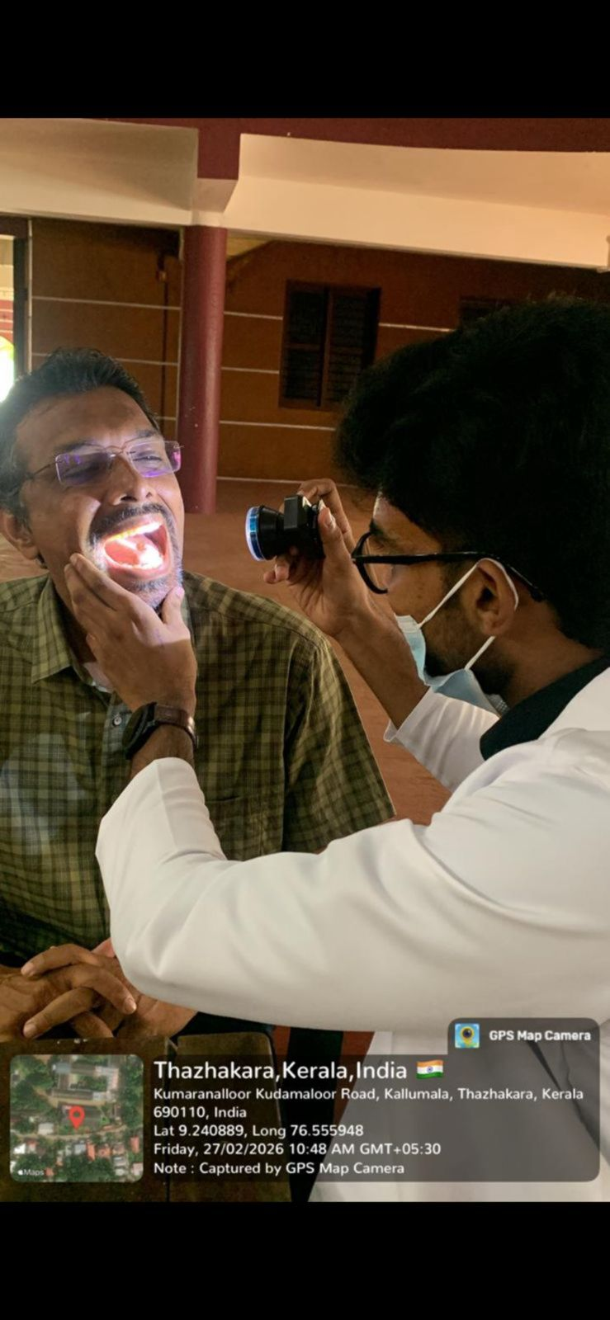

Venue: Mar Ebnezer Church

Date : 28-02-2026

Time: 10:00 am -2:00pm

Camp Statistics

No of Patients: 26

Sl no | Gender | Decay (%) | Gum disease (%) | Malocclusion (%)
1 | Males (11) | 59 | 32 | 45
2 | Females (15) | 71 | 44 | 42

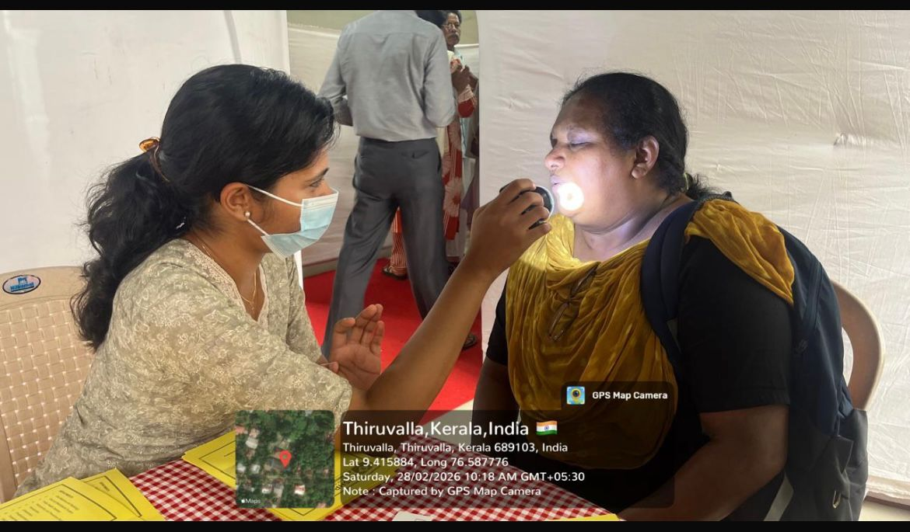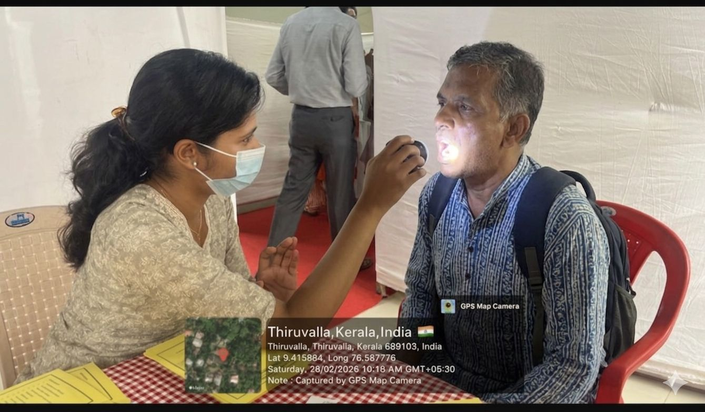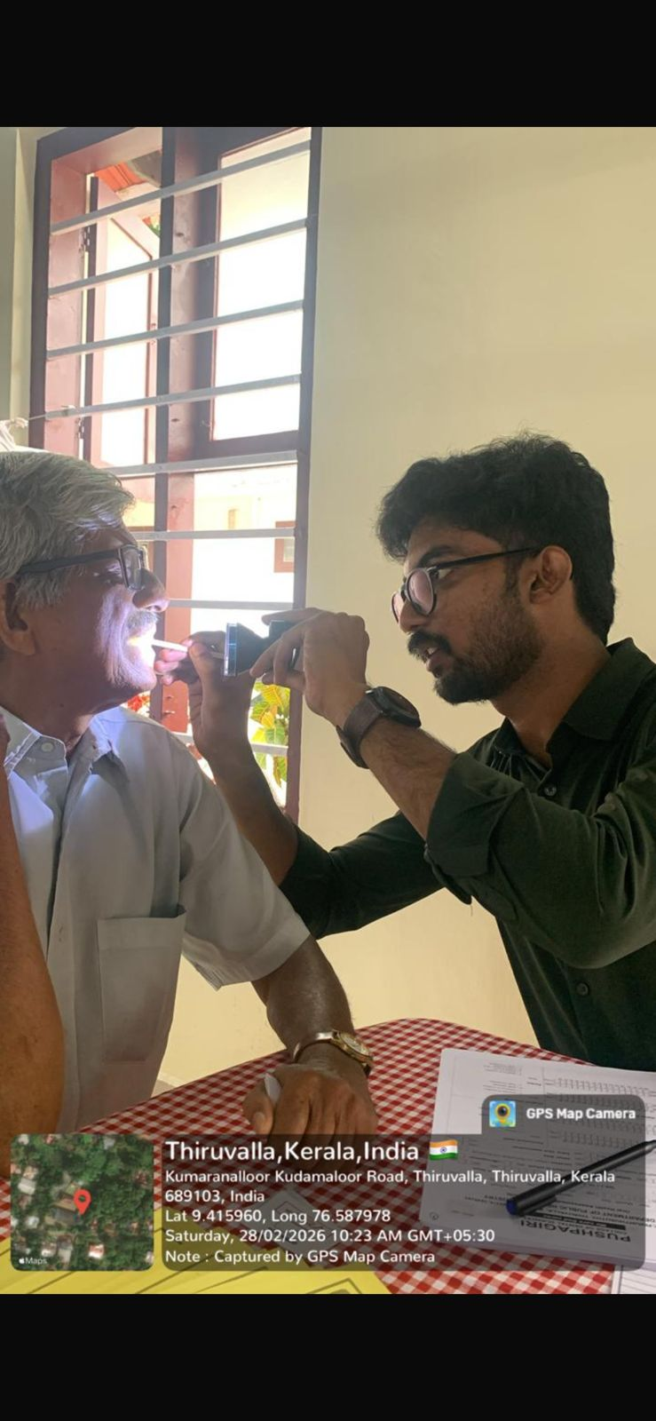

Date: 01.03.26 Time: 9.00-1.00pm
Venue: Abayam Charitable society Koruthode

CAMP STATISTICS
- No of patients: 30

Sl no | Gender | Decay (%) | Gum disease (%) | Malocclusion (%)
1 | Males (6) | 100% | 100% | 46%
2 | Female (24) | 80.7% | 84.6% | 46%

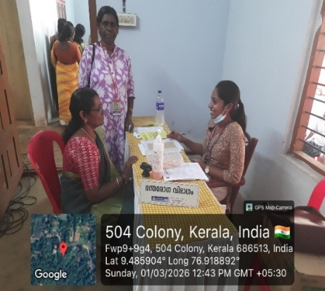
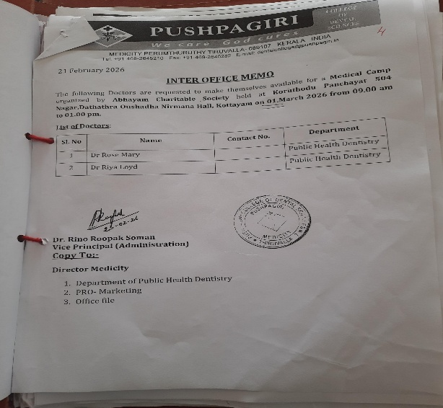

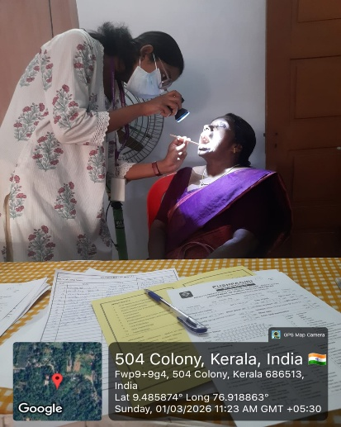

VENUE : ARCHBISHOP MAR GREGORIOS PUBLIC SCHOOL
DATE : 3-3-2026
TIME: 9.30am-2.30pm

CAMP STATISTICS

No of Patients: 270

Sl no | Gender | Decay (%) | Gum disease (%) | Malocclusion (%)
1 | Males (131) | 53.4 | 27.4 | 15.2
2 | Females (139) | 53.9 | 38.1 | 45.3

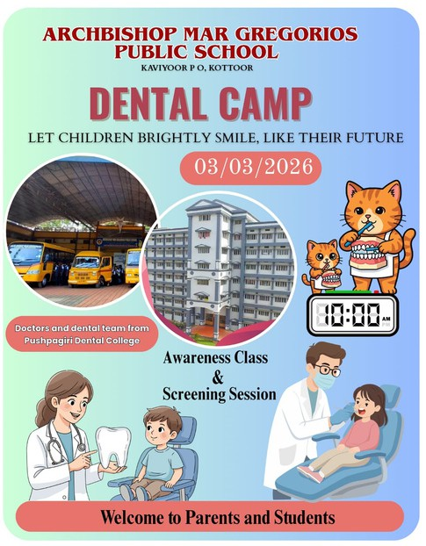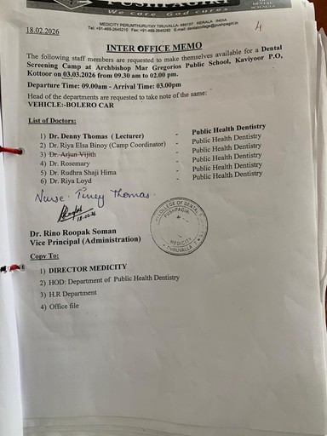

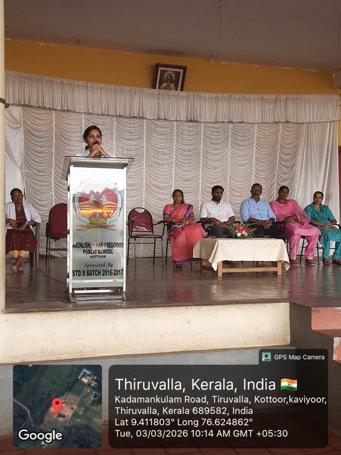
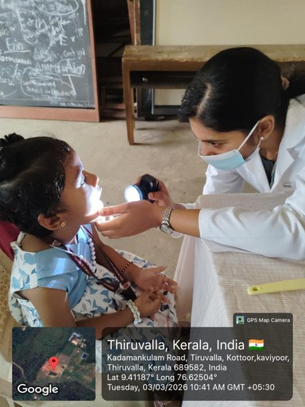

Venue: Winneland Academy, Adoor, Pathanamthitta
Date : 12-03-2026
Time: 10:00 am -1:00pm

CAMP STATISTICS
No. Of patients: 36

Sl no | Gender | Decay (%) | Gum disease (%) | Malocclusion (%)
1 | Males (22) | 59% | 20% | 45%
2 | Females (14) | 71% | 10.5% | 42%

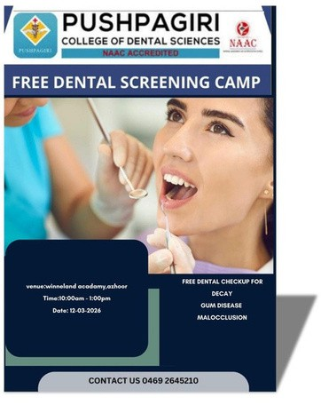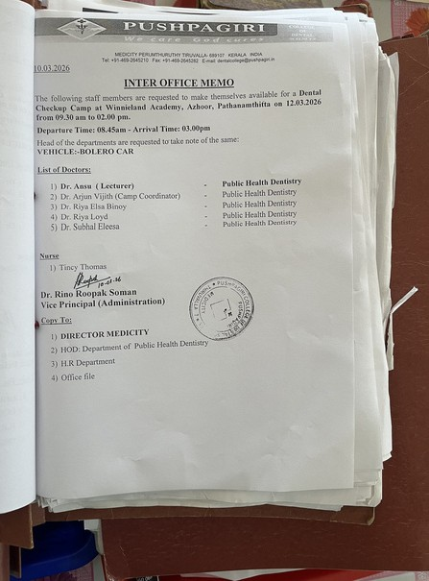

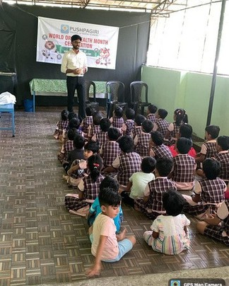
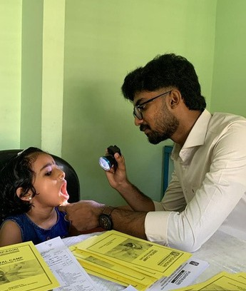

Venue: T.I.M.E kids Preschool, Thiruvalla
Date : 13-03-2026 Time: 10:00 am -1:00pm

CAMP STATISTICS:
No of Patients: 40
Sl no | Gender | Decay (%) | Gum disease (%) | Malocclusion (%)
1 | Males (19) | 33 | 20 | 5
2 | Females (21) | 42 | 10.5 | 0

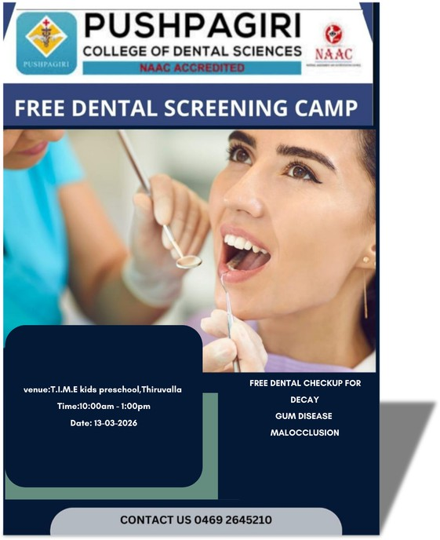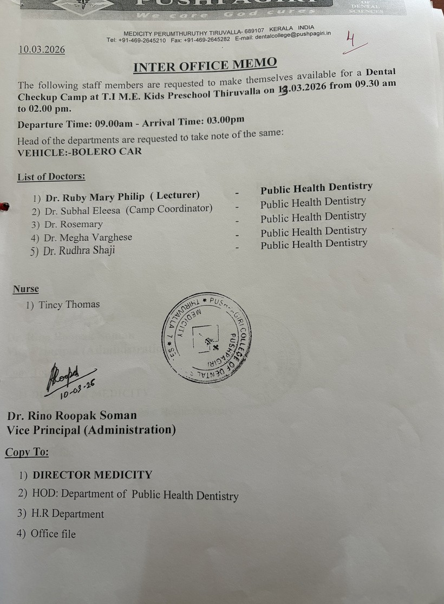
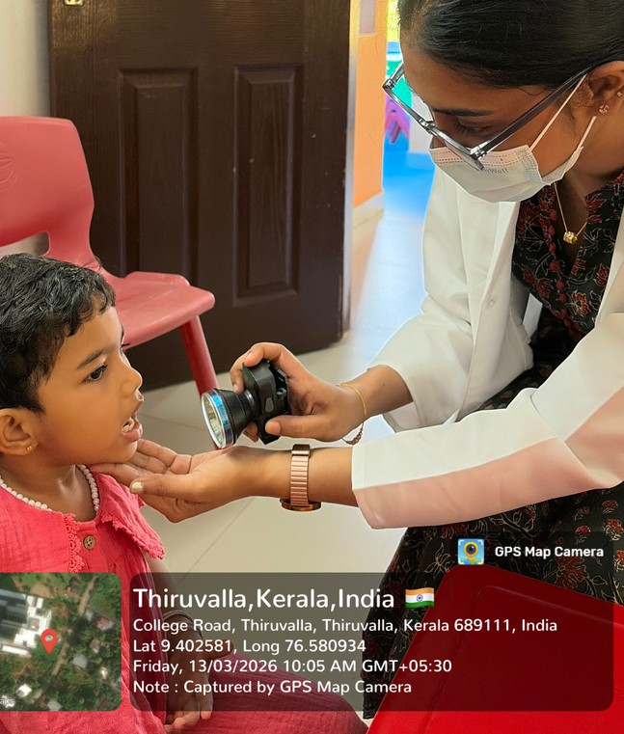
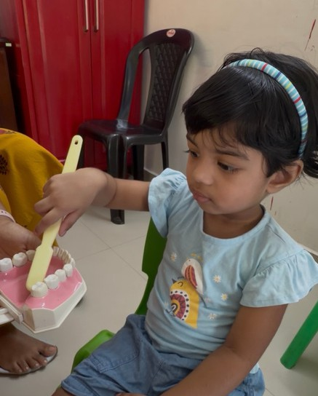

Venue: Snehatheeram Pakalveed, Venpala , Thiruvalla
Date: 14-03-2026 Time: 9am-3pm

CAMP STATISTICS
No of patients: 30
Sl no | Gender | Decay (%) | Gum disease (%) | Malocclusion (%)
1 | Males (19) | 53 | 98 | 5
2 | Females (11) | 45 | 72 | 36

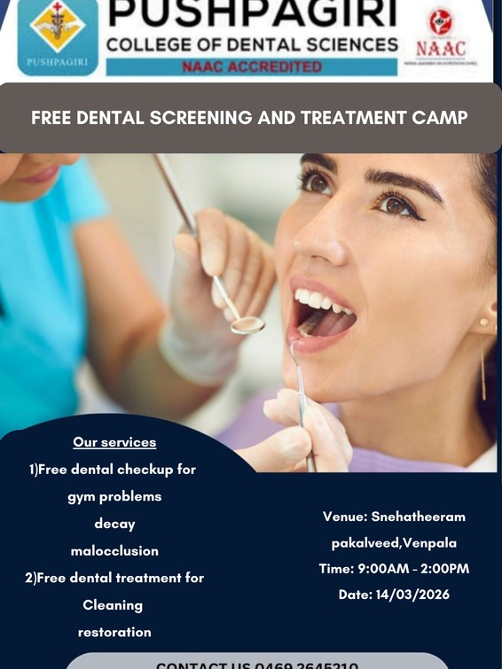
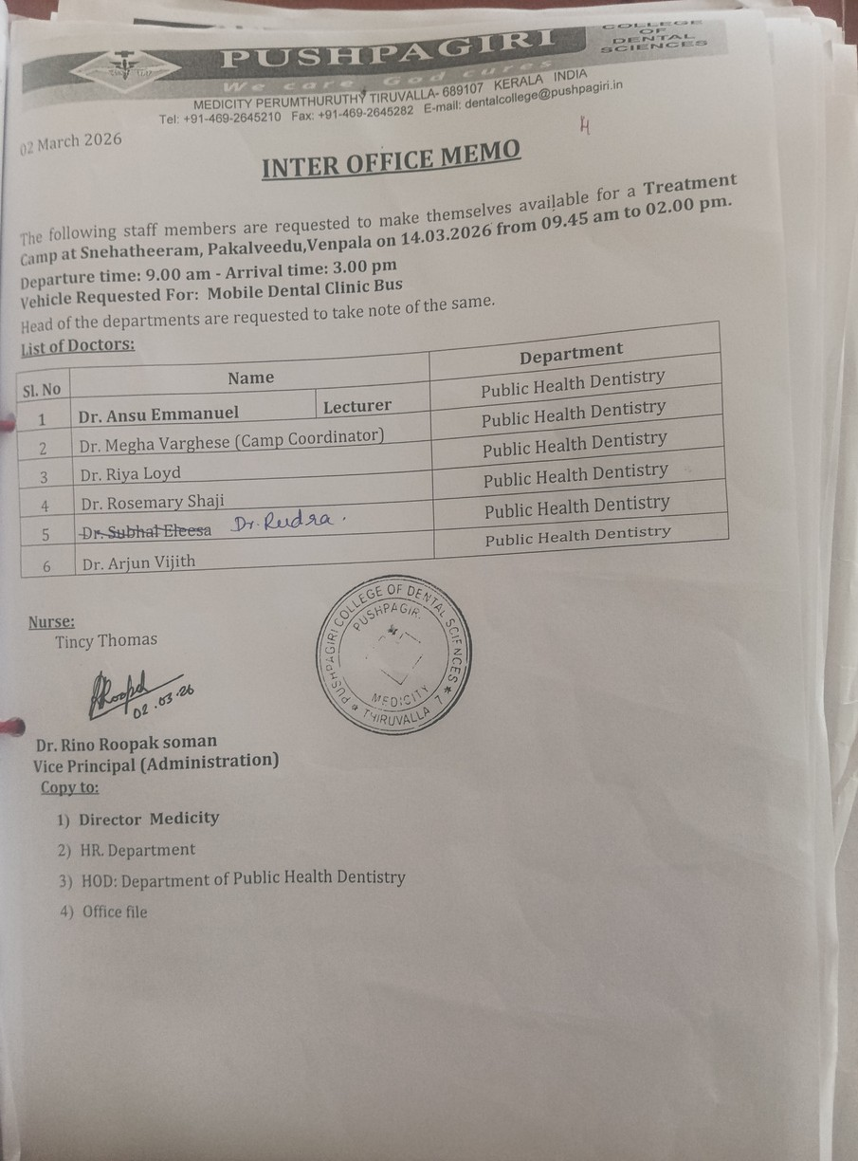
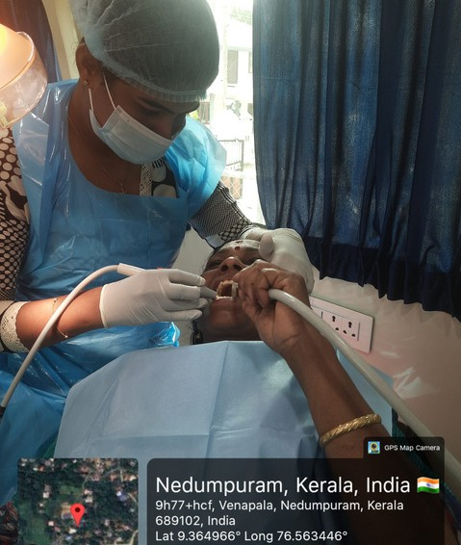
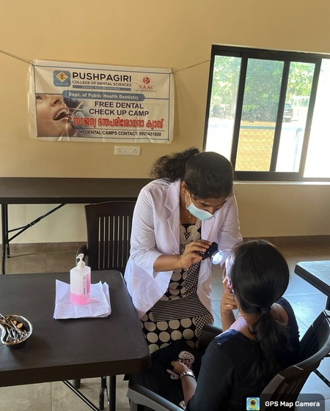

Venue : Sahrudaya special school for mentally challenged, Ramankary, Alappuzha
Date : 16/03/2026 Time : 9.45 am to 2.00 pm

CAMP STATISTICS
- No. of patients : 53

SI no. | Gender | Decay(%) | Gum disease  (%) | Malocclusion  (% )
1. | Males (34) | 73% | 70% | 20%
2. | Females (19) | 73% | 63% | 20%

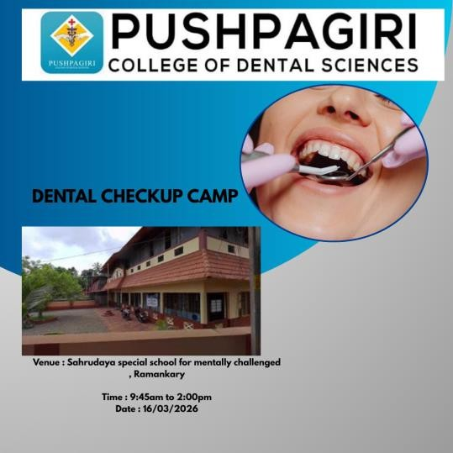

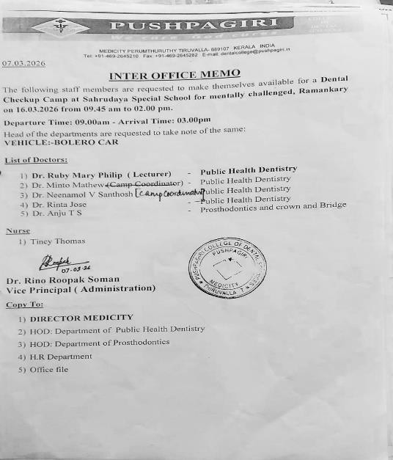
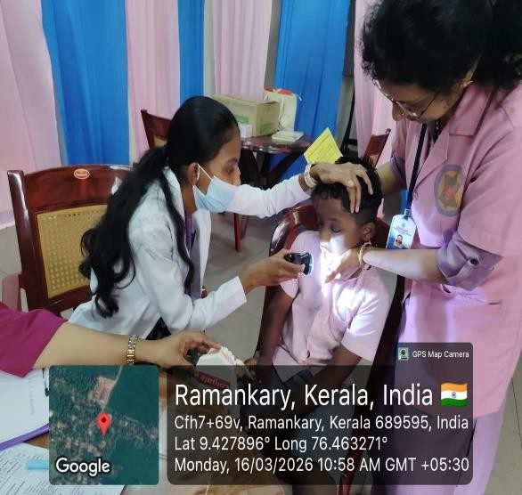

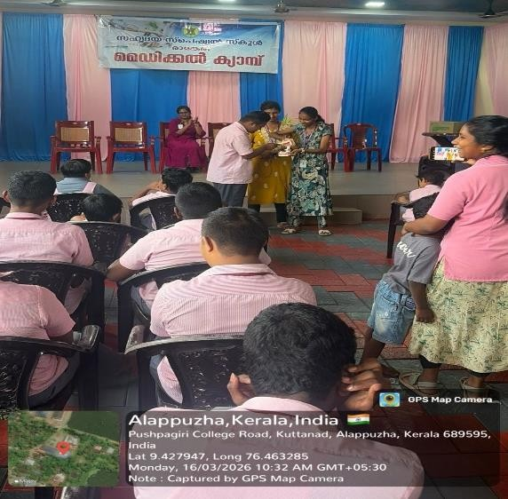

Venue: Laila’s Preschool Tukalassery, Thiruvalla
Date: 18.03.2026 Time: 9.30 am - 3.00 pm

CAMP STATISTICS
- No. of patients: 53

SI no. | Gender | Decay(%) | Gum disease  (%) | Malocclusion  (% )
1. | Males (34) | 73% | 70% | 20%
2. | Females (19) | 73% | 63% | 20%

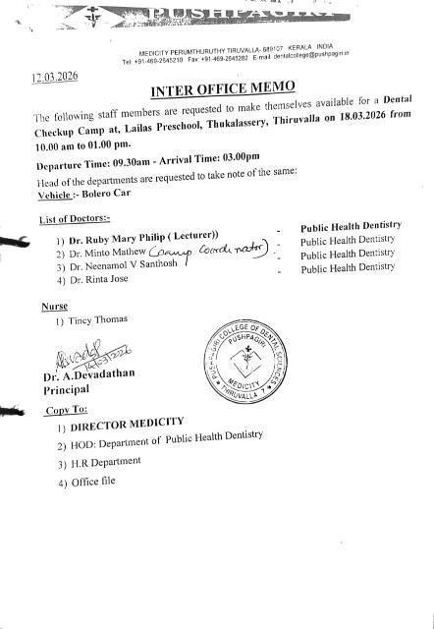

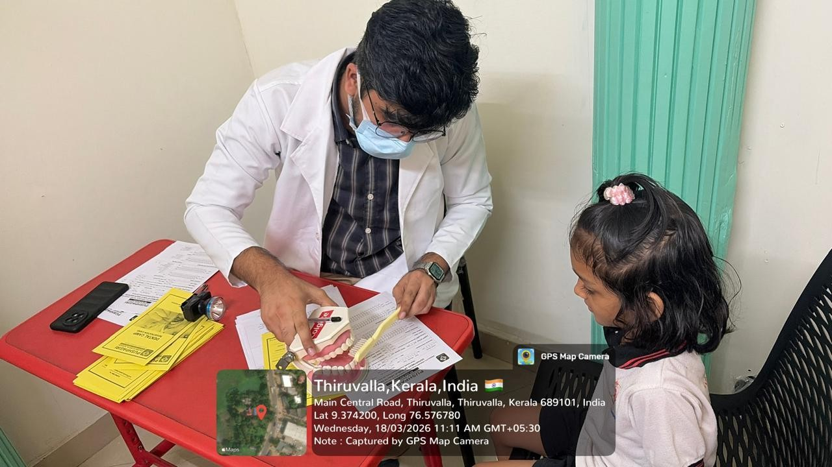

Venue: SBI General Insurance Limited, Kottayam
Date: 21-03-2026
Time: 10:00 am -2:00pm
CAMP STATISTICS
No. Of patients: 14

Sl no | Gender | Decay (%) | Gum disease (%) | Malocclusion (%)
1 | Males (8) | 59 | 32 | 45
2 | Females (6) | 71 | 44 | 42

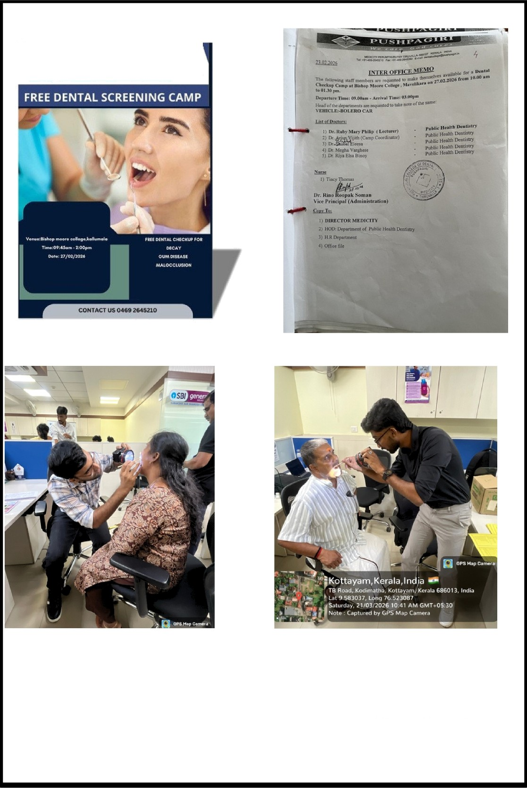

Date: 21.03.2026
Time: 9.30 am - 3.00 pm
Venue: St Mary’s Church, Ittithanam, Changanacherry
CAMP STATISTICS
No. of patients: 42

Sl no | Gender | Decay (%) | Gum disease (%) | Malocclusion (%)
1 | Males (20) | 40 | 85 | 5
2 | Females (22) | 68 | 81 | 8

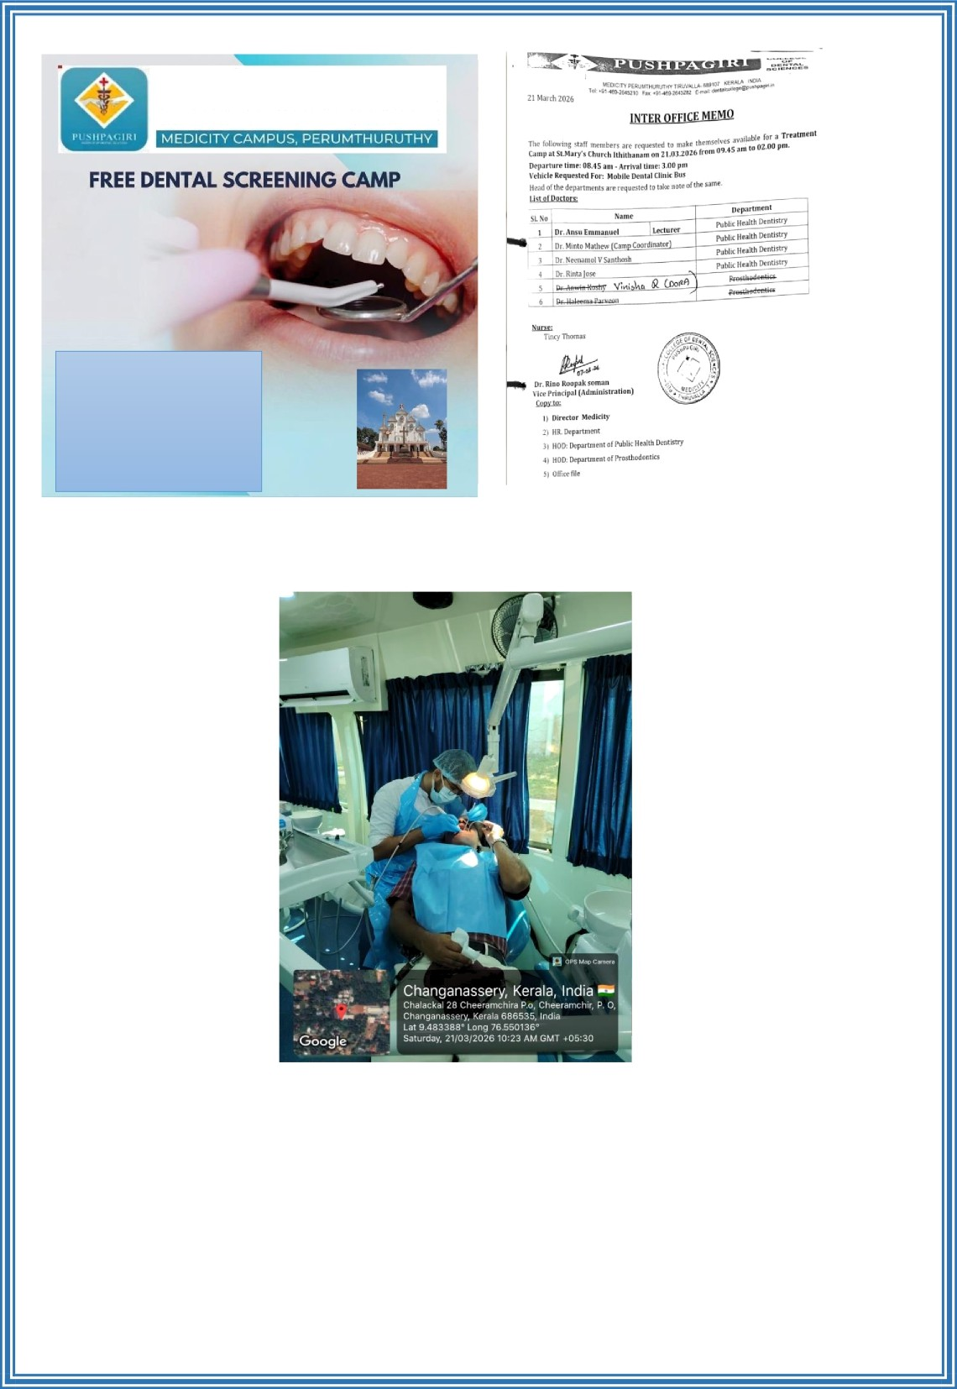

Venue: St John’s Puthenpally Chinagavanam, Changanacherry

Date: 22.03.2026
Time: 9.45 am - 2.00 pm

CAMP STATISTICS
No. of patients: 96

Sl no | Gender | Decay (%) | Gum disease (%) | Malocclusion (%)
1 | Males (57) | 50 | 56 | 15
2 | Females (39) | 51 | 58 | 18

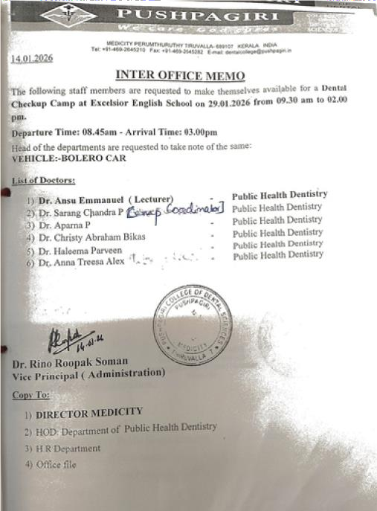
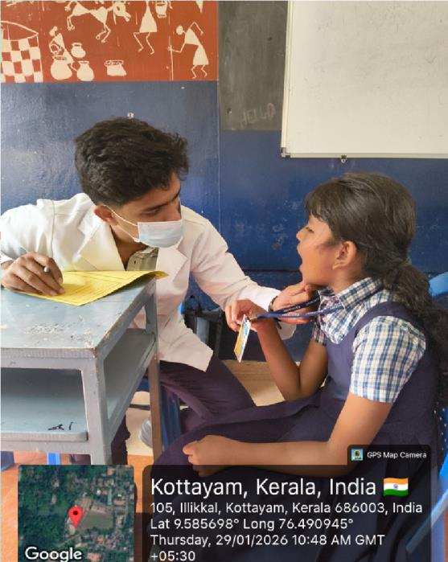
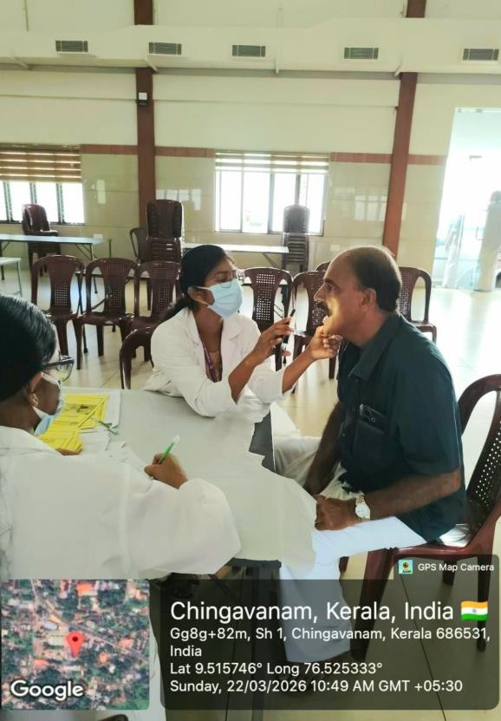
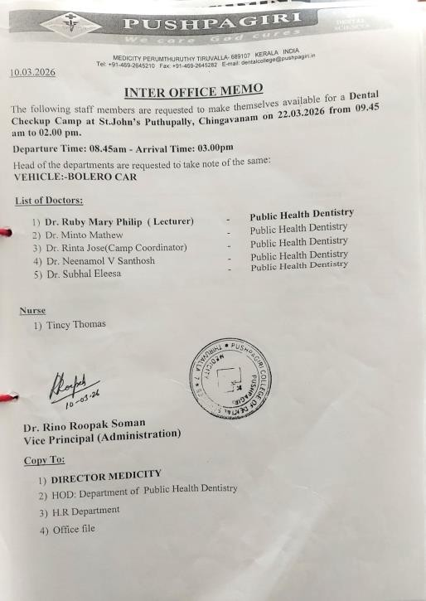
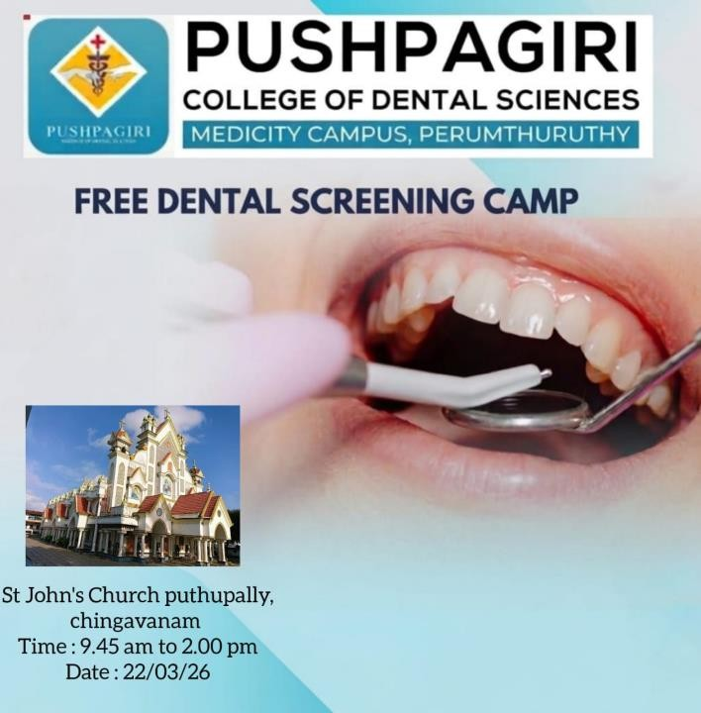

Venue: TIME kids Kindergarden, Thuruthy, Changanacherry

Date: 23.03.2026
Time: 9.30 am - 3.00 pm
CAMP STATISTICS
No of Patients: 16

Sl no | Gender | Decay (%) | Gum disease (%) | Malocclusion (%)
1 | Males (10) | 80 | 80 | 0
2 | Females (6) | 66 | 66 | 0

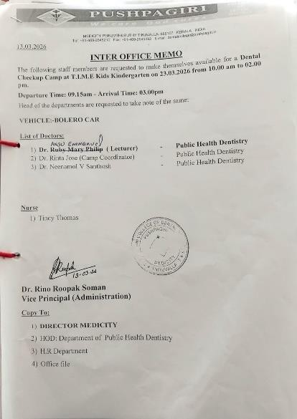
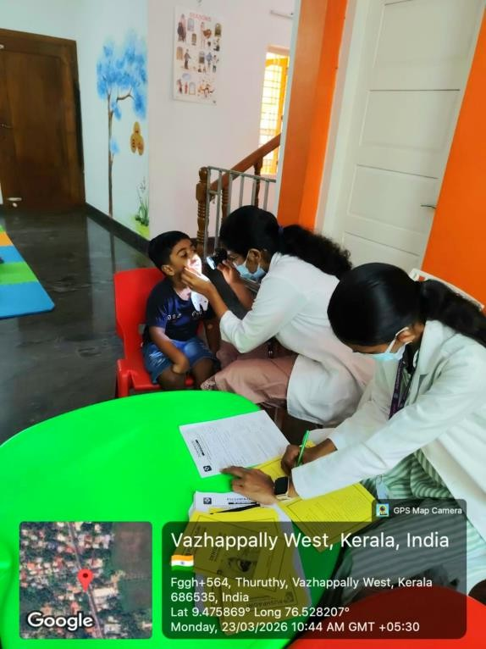
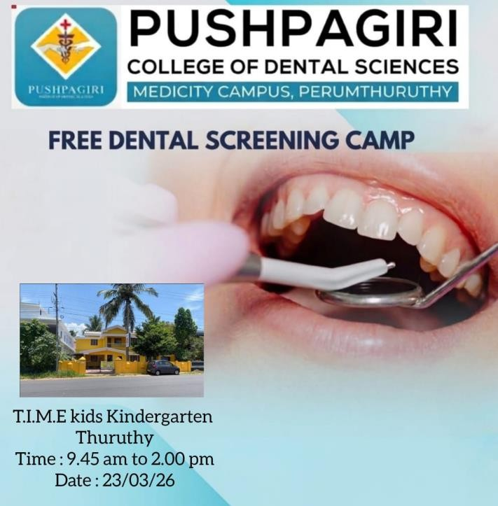

Venue : Abhaya Bhavan Society, Thiruvalla
Date : 30/03/2026
Time : 2:00pm to 4:00pm

CAMP STATISTICS
- No.of patients : 26

Sl no | Gender | Decay (%) | Gum disease (%) | Malocclusion (%)
1 | Males (2) | 50% | 100% | 0%
2 | Females (24) | 37.5% | 70% | 0%

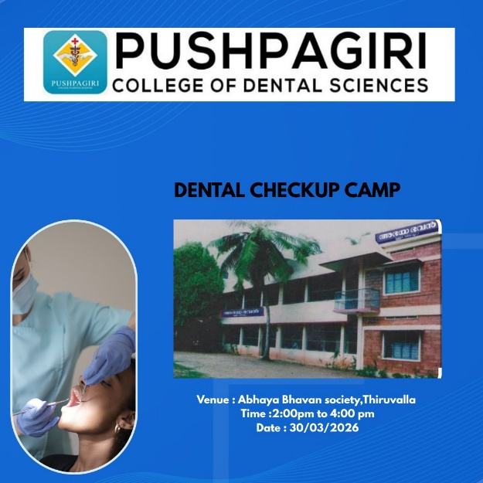

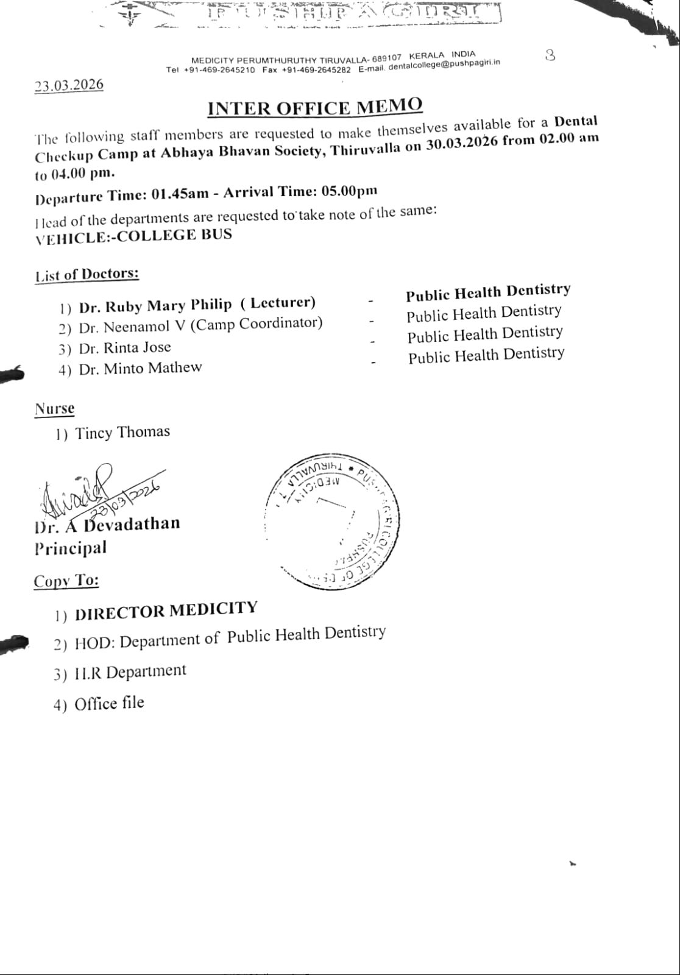

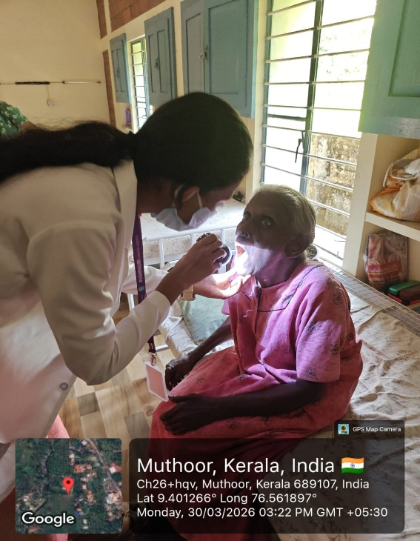

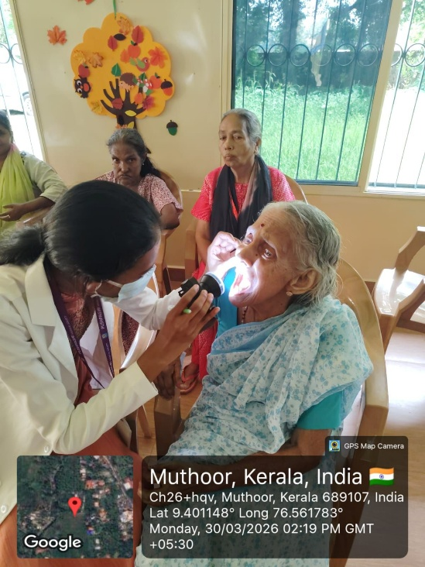

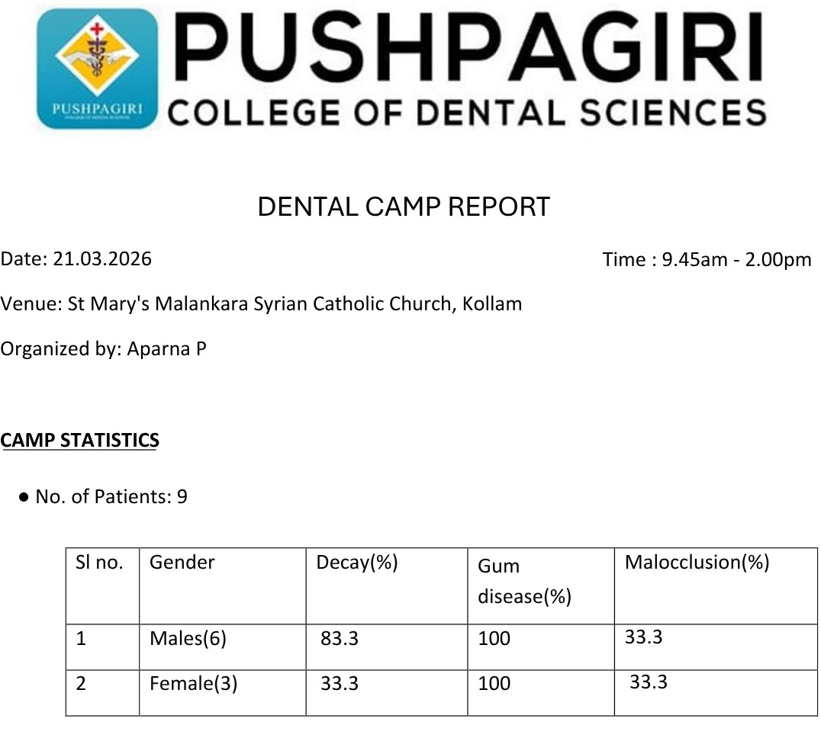

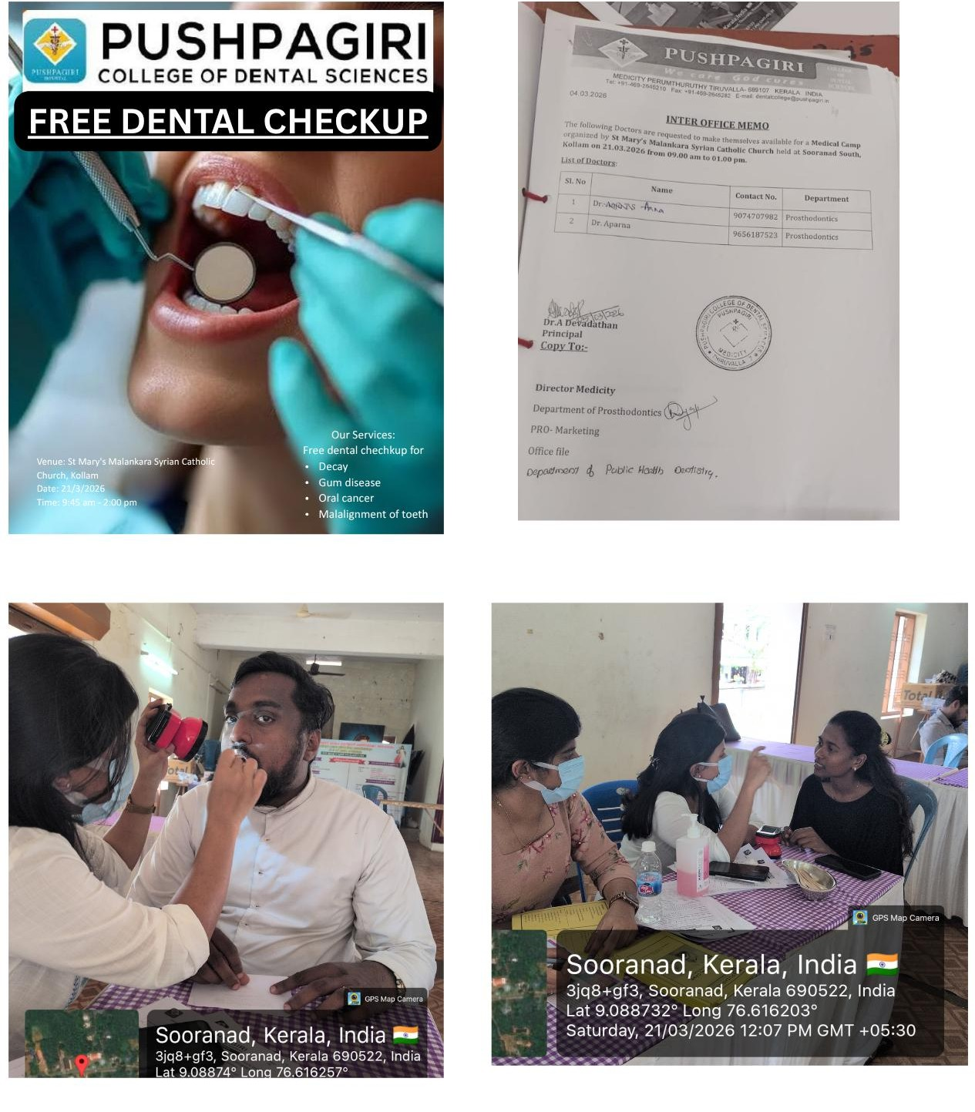

Venue: Sacred Heart Church, Thottakkadu, Kottayam

Date: 12.04.2026 Time: 9.45 am -2.00 pm

CAMP STATISTICS

● No. of patients: 94

Sl no | Gender | Decay (%) | Gum disease (%) | Malocclusion (%)
1 | Males (37) | 48.6% | 75.6% | 18.9%
2 | Females (57) | 47.3% | 75.4% | 33.3%

DENTAL CAMPS BENEFICIARIES: 5305

ORAL HEALTH AWARENESS VIDEOS

Topical Fluoride
An oral health awareness video in topical fluoride was created to stress the importance of topical fluoride application for children to prevent dental caries among them. The video highlights the benefits of topical fluoride application in prevention of dental caries both in the primary dentition and permanent dentition. The video is a 3-minute video for creating awareness among parents. The video was posted in social medias like Instagram and Facebook for maximum coverage.

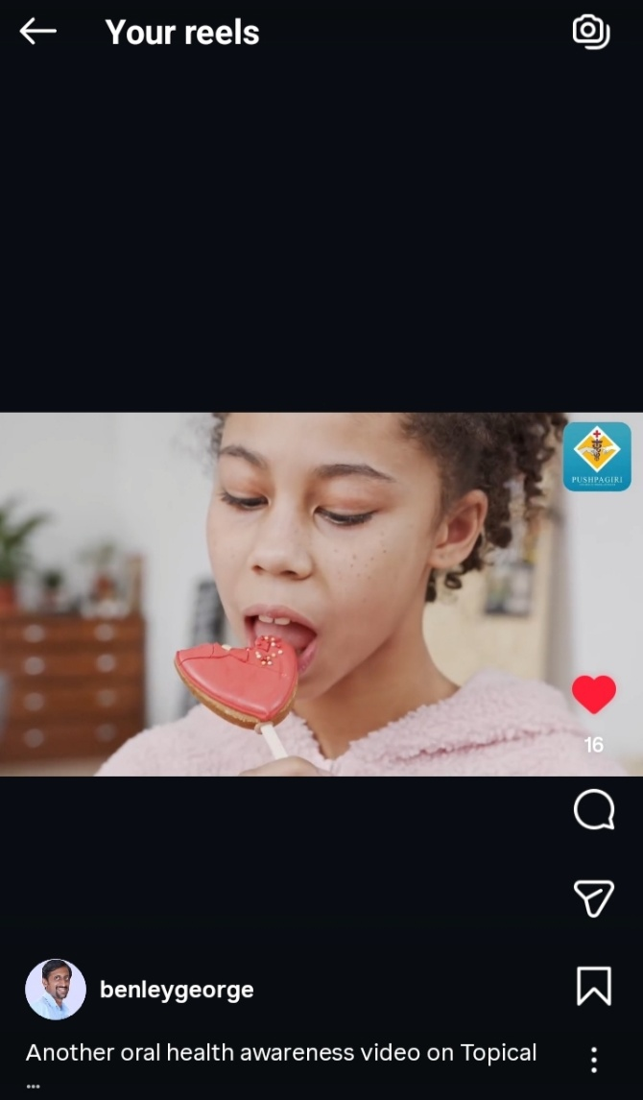

Dental Sensitivity

The next oral health awareness video on Dental sensitivity to create awareness on the causes of dental sensitivity, treatments available and measures to prevent dental sensitivity. The video is a 3-minute video for creating awareness among the community of all age groups. The video was posted in social medias like Instagram and Facebook for maximum coverage.

